**Online Store**

**Management System**

Vamsi Charan Adari

Zeel Sureshbhai Prajapati

Romana Khatoon

A project submitted in partial fulfillment of the requirements for the course

CPS 510 Systems Analysis

*Advisor*

Dr. Raghava Gowda

December 4, 2018

Department of Computer Science

University of Dayton

**Systems Analysis Project**

**Semester:** 1st Semester **CPS:** 510  **Team No:** 18_FA_SA_T6

**Project Name:** Online Store Management System

**Team Members:** Vamsi Charan Adari **Team Leader**

Zeel Sureshbhai Prajapati

Romana Khatoon

**Table of Contents**

|  |  |  |  |
| --- | --- | --- | --- |
|  | **Team Profile** (max two pages**)** | **1-2** |  |
|  | **Project Metrics** | **5-6** |  |
|  | **Details of Phase I and**  **Phase II Revisions** | **7** |  |
|  | **Phase I and II Grade Sheets** (old TOC) | **8** |  |
|  | **Presentation Slides** PPT |  |  |
| **A** | **PROJECT DOCUMENT** | **Page No** | **Comments** |
| 1 | **Project Statement**  **Main Functions**  **Research** &similar software in use or development (public domain, GitHub etc.)  **Development Platform, Language, IDE**  **Importance of the Project** | 9  9  10  10  10 |  |
| 2 | **Process Description**  (detailed ~20 Pages) | 11-31 |  |
| 3 | **Work Assignments to Team Members**  PERT/Gantt Charts  Coordination and Integration Process | 129-131 |  |
| 4 | **Requirements Specification**  **by Use Case Diagrams:**  **Use Case Diagrams**  **Use case Descriptions**  **Activity Diagrams**  **Screens/Reports**  Statecharts | 32-94 |  |
| **B** | **Analysis Models: DFD, Object-oriented Analysis and Design and  E-R Models** | 96-101 |  |
| 5 | **DFD**  Context Level DFD  Detail Data Flow Diagrams  Total No of Processes  No of Structured English – written  No of Pseudocodes – written  No of Data Flows – defined  No of Data Stores –defined  Decision Tables / Decision Trees  **No of E-R Diagrams**  Total Entities in the above ER diagrams  **Domain Class Diagrams**  Total no of classes defined in the Domain Class Diagrams  Activity Diagrams  Statecharts | 96-119 |  |
| **C** | **Design Models:  Object-oriented Design** | 120-121 |  |
| 6 | ***Use Case Realization: UML Model by use cases***  Total no of System Sequence Diagrams (SSD)  Modified Domain Class Diagrams  CRC Cards  Detailed Sequence Diagrams  Design Class Diagrams (updated domain class diagrams)  Activity Diagrams  Statecharts  Component Diagrams  Deployment Diagram and/or  System Flow Chart | 120-132 |  |
| **D** | **Implementation** | -------- |  |
| 7 | **Code Organization by Member, Modules: Language**  Project Directory and contents  Snapshot  Navigation Chart and other code traversal diagrams  Programs, Author and size in LOC  **Borrowed code, description, LOC, source, URL**  **Test Cases and Reports** | ---------- |  |
| 8 | **User Guide**/**Installation Guide** | -------- |  |
| **E** | **ETHICAL DILEMMA** in this project | 133 |  |
| 9 | **Othe**r **documentation** and research pertaining to the project | -------- |  |
| **F** | **Project Evaluation** by the Team | 133 |  |

**Project Metrics**

**SYSTEMS ANALYSIS TEAM PROJECT**

**Semester:** 1st Semester **Course:** CPS 510 **Team No:** 18_FA_SA_T6

**Members in the Team:** Vamsi Charan Adari, Zeel Sureshbhai Prajapati, Romana Khatoon

**Project Name:** Online Store Management System

|  |  |  |  |  |
| --- | --- | --- | --- | --- |
|  |  | No of Pages/ artifacts | Per  Member |  |
| **1** | **Project Statement** | 2 | 1 |  |
| **2** | **Project Description**  (~20 Pages) | 20 | 7 |  |
| **3** | **Requirements by Use Cases** | ---- | ---- |  |
|  | Total No of Use Case Diagrams | 6 | 2 |  |
|  | Total No of Use Cases | 29 | 10 |  |
|  | No. of Use Cases Described | 29 | 10 |  |
|  | No of Screens/Reports | 26 | 9 |  |
|  | No of Activity Diagrams | 29 | 10 |  |
|  | Work in IBM Rational Software Architect (Yes/No) Adequacy  Screens/ Reports (Tools/Manual) | ----- | ------ |  |
| **4** | **Structured Systems Analysis** | ----- | ----- |  |
|  | Total No of Data Flow Diagrams  Total No of Processes | 2  12 | 1  4 |  |
|  | No of Structured English | 6 | 2 |  |
|  | No of Pseudocodes | 10 | 3 |  |
|  | No of Data Stores defined | 23 | 8 |  |
|  | No of Data Flows defined | 20 | 7 |  |
|  | No of E-R Diagrams  No of Entities in the above E-R diagrams | 1 | 1 |  |
|  | Work in Visible Analyst Workbench  (Yes/No) Adequacy | ----- | ----- |  |
| **5** | **Object-Oriented Analysis and Design** | ----- | ------ |  |
|  | No of Domain Class Diagrams  Total Number of Classes in the above diagrams | 1  1 | 1  1 |  |
|  | No of System Sequence Diagrams | 6 | 2 |  |
|  | No of CRC Cards | 9 | 3 |  |
|  | No of DETAILED Sequence Diagrams | 6 | 2 |  |
|  | No of classes in the final Design Class Diagram (modified Domain Class if needed) | 8 | 3 |  |
|  | Component Diagrams | 1 | 1 |  |
|  | Deployment Diagrams | 1 | 1 |  |
|  | Work in IBM Rational Software Architect (Yes/No) Adequacy | ----- | ------ |  |
| **6** | **IMPLEMENTATION**  **Language: _________** | ----- | ------ |  |
|  | Total no of Lines of Code (LOC) | ----- | ----- |  |
|  | No of Database Tables implemented | ----- | ----- |  |
|  | No of pages of User Guide/Installation Guide | ----- | ----- |  |
| **7** | **No of Pages on Ethical Issues** | 1 | 1 |  |
| **8** | **No of Pages on Project Evaluation** | 1 | 1 |  |
| **9** | **Time Report included (YES/No)** | Yes | Yes |  |
|  | **For Instructor only:** |  |  |  |
|  | Analysis Quality |  |  |  |
|  | Design Quality |  |  |  |
|  | Code Quality |  |  |  |
|  | Notations and Model Accuracy |  |  |  |
|  | **Overall Grade** |  |  |  |

**Teamwork Information/Time Report**

|  |  |  |  |  |
| --- | --- | --- | --- | --- |
| **Team Member/Hours by phase** | **No. of hours**  **by member**  **Phase I** | **No. of hours**  **by member**  **Phase II** | **No. of hours**  **by member**  **Phase III** | **Total Hours** |
| **Leader:** Vamsi Charan Adari | **6** | **10** | **10** | **26** |
| Member1: Zeel Sureshbhai Prajapati | **6** | **10** | **10** | **26** |
| Member2: Romana Khatoon | **6** | **10** | **10** | **26** |
| **Team hours by phase**  **(Please do not include individual hours here)** | **3** | **8** | **12** | **23** |
| **Total no of hours per phase** | **21** | **38** | **42** | **91** |

**Details of Phase I and Phase II Revisions**

* Completely modified Use Cases which includes all the use cases in functioning of an Online Store Management System.
* Designed activity diagrams for all the use cases.
* Reshaped DFD diagrams:
  + Added additional entity “Applicant” in Context Level Diagram.
  + Added additional processes and datastores for the entire processes in Level – 0 Data Flow Diagram.
* Organized project orderly and divided according to Use Cases in the project.
* Wrote Structured English for all the entities.
* Wrote Pseudo Code for all the processes in the Level – 0 DFD.
* Modified Table of Contents and data content in Data stores and Data Flows.

**Phase I and II Grade Sheets** 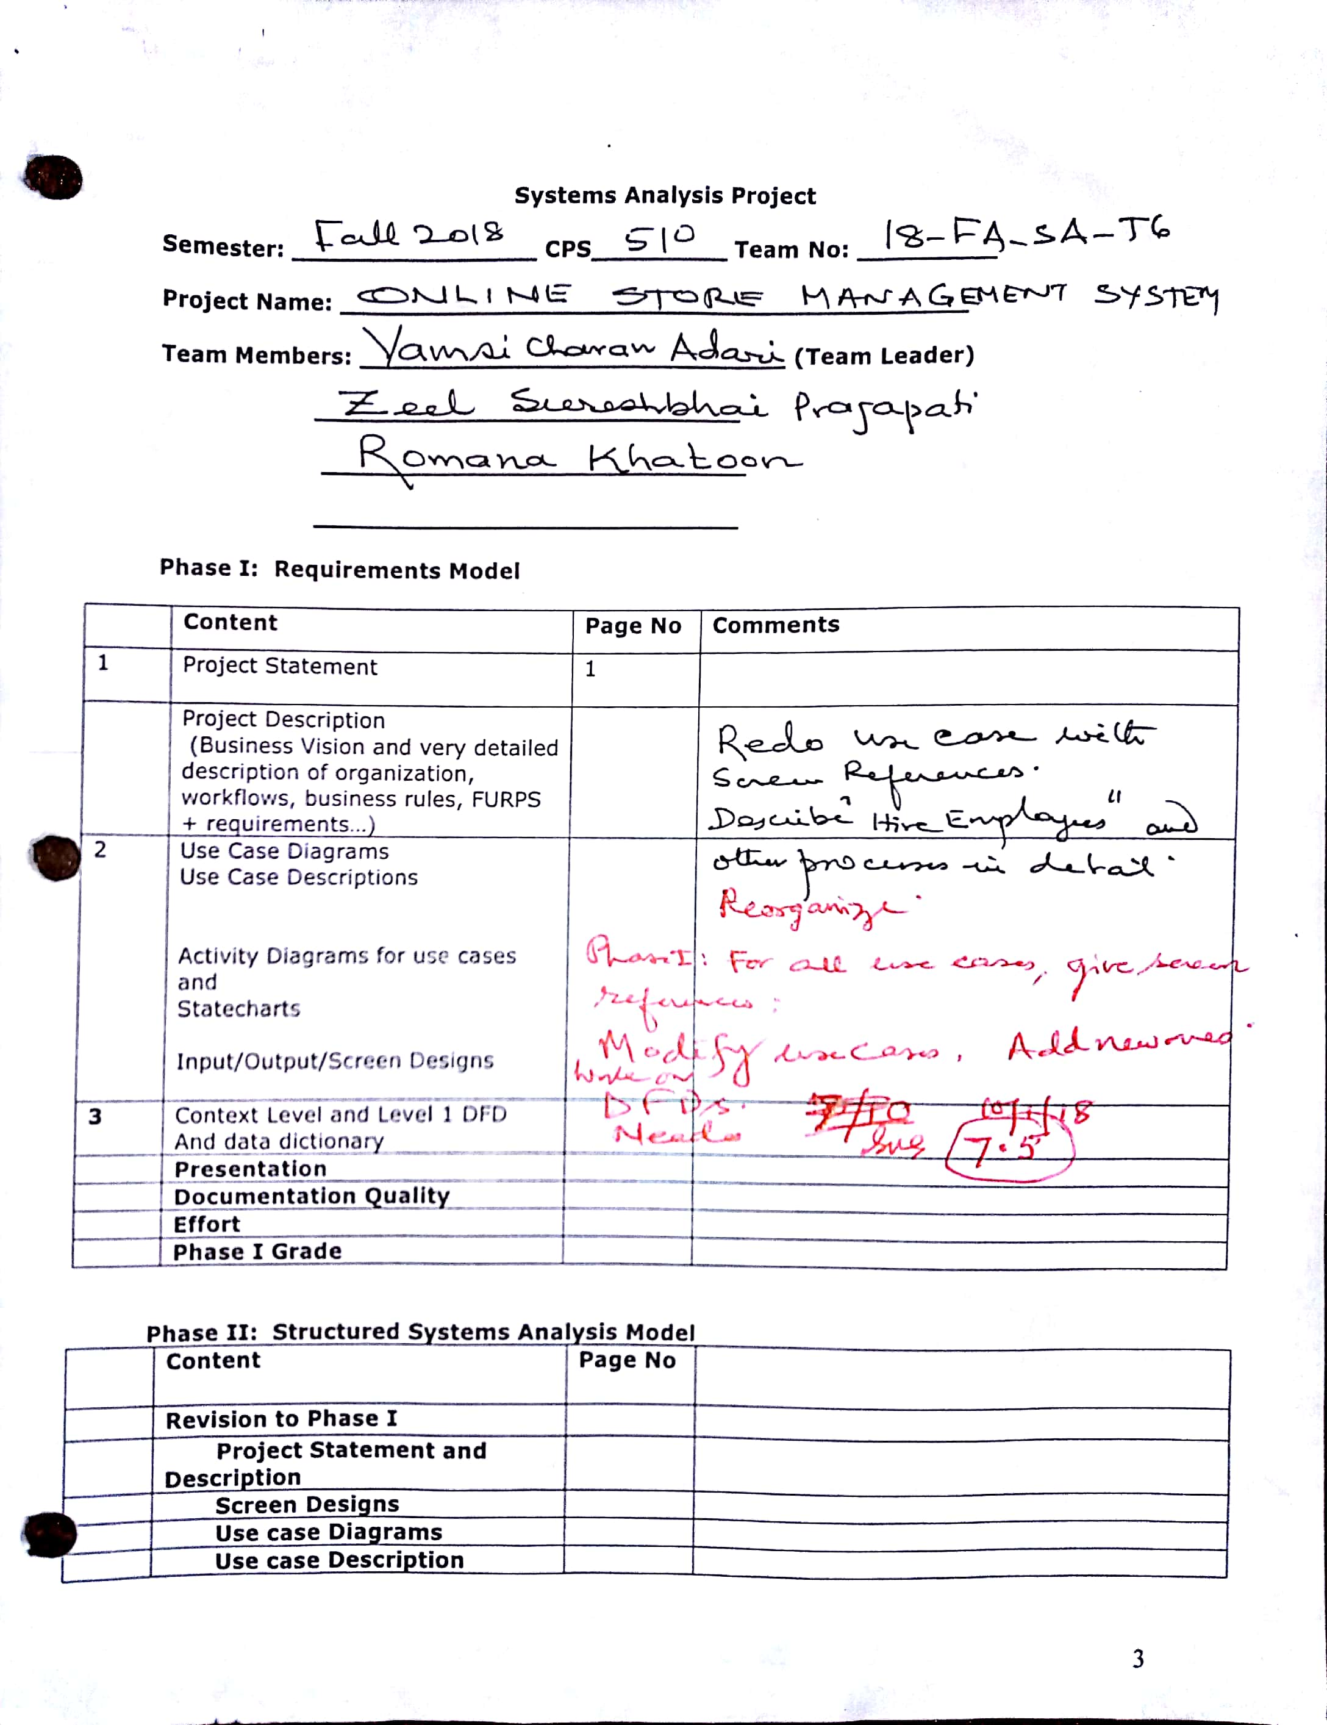

**PROJECT STATEMENT:**

To develop a systems analysis project for managing system of an online store which would sell products online from supplier.

**NEED:**

Online store management system allows merchants of all types throughout the world to advertise and sell the products online and even buy products from different merchants. One need not worry about the stock or storage space where online store becomes a platform for suppliers and buyers.

**GOALS & OBJECTIVES:**

The objective of this project is to create an Online Store Management System which is a Web Portal with content management system which allows the information of products to available throughout the internet.

**MAIN FUNCTIONS:**

To develop a plan, it is essential to understand requirements of the Online Store Management System.

The major functions supported by the system would include:

1. Products, Buyers and Suppliers Information.
2. Coupons, Affiliates, Promo Codes and Discount Managements.
3. Sales of Products(Payments).
4. Tracking of Shipments.
5. Create accounts for employees, managers, customers to access the system.
6. Hire, Pay and Schedule Employees.

**IMPLEMENTATION PLAN:**

The creation of an implementation plan is essential to obtaining financing and gives the business direction of the project. Creation of an implementation plan gives the owner a realistic approach to short-term analysis of the online portal for the next three to five years.

**RESEARCH:**

Online store management system is like Amazon.com, E-Commerce websites who online websites as a platform to connect with their customers and delivers their products. There are lot of tech giants who are using online store as their source.

**DEVELOPMENT PLATFORM:**

Windows XP, Vista, 7, 8 and 10. Linux and Mac.

**LANGUAGE:**

1. HTML, CSS and JavaScript.
2. JSP and Servlets.
3. PHP and Wamp Server.

**IDE:**

Notepad++, Netbeans, Eclipse and Atom.

**IMPORTANCE OF THE PROJECT:**

Now-a-days online store makes a huge change and is very popular. It is a store where customers can interact with company directly to gather information, buy products, sell products and know new products in market. Virtual stores are deployed over internet which are available throughout the world and can be easily accessed.

**PROJECT DESCRIPTION:**

To build up a product venture the executives plan for overseeing Data Framework for a supermarket which would move things in a physical store and on the web.

With the end goal to build up an arrangement, it is basic to comprehend the prerequisites of the Data Framework.

Being a sole network supplier, the market offers basic supply items to the nearby network and encompassing zone of roughly 4,000 natives. Regularly referenced as a mainstay of the network, the network's suitability is needy upon the accomplishment of their neighborhood showcase. Without a fruitful column, for example, the market, the network would waver and steadily decay. It has been oftentimes referenced that a solid network is reliant upon the achievement of its organizations.

**Mission**

RG Grocery Store is committed to satisfying customers by providing a broad selection of high quality and competitively priced products as well as exceptional customer service. The focus of RG Grocery Store is to create an environment that is warm, friendly, and clean. We are committed to our employees by treating them with respect, fairness and integrity and exposing them to an atmosphere that fosters teamwork and professional development.

The suppliers of RG Grocery Store are also partners in the success of the company and we expect the same in return. It is our responsibility to be active stewards in our communities and to promote local involvement.

The keys to success for RG Grocery Store are:

• Quality products and friendly service.

• Maintaining existing loyal customer base.

• Creating a positive relationship within the community.

**Business Plan Document**

RG Supermarket, Inc. is a standard and enlisted supermarket business that will be in one of the busiest lanes in Orlando, Florida. We have could rent an office that is sufficiently enormous (a 15 thousand square foot office) to fit into the structure of the sort of market that we plan propelling and the office is in a corner piece straightforwardly inverse the biggest private home in Orlando, Florida.

RG Market, Inc. will retail an extensive variety of sturdy merchandise and non – tough products at reasonable costs from various brands. We will take part in retailing general lines of sustenance items, including new and arranged meats, poultry and fish, canned and solidified nourishments, crisp leafy foods and different dairy items et al.

We know that there are a few expansive and little chains of general store/supermarket outlets all around Orlando, which is the reason we invested energy and assets to direct our practicality studies and market review to offer considerably more than our rivals will offer. We have self – benefit choices for our clients, and our outlet is very much anchored with the different installment choices.

Considerably more than moving the merchandise and results of best brands in the assembling and sustenance industry, our client care is second to none in the entire of Orlando, Florida. We realize that our clients are the motivation behind why we are good to go which is the reason we will go the additional mile to get them fulfilled when they visit our market and furthermore to end up our devoted clients and ministers.

RG Market, Inc. will guarantee that every one of our clients are given top of the line treatment at whatever point they visit our supermarket. We have a CRM programming that will empower us to deal with a one on one association with our clients regardless of how extensive the quantities of our clients' base may develop to. We will guarantee that we get our clients associated with the choice of brands that will be on our racks and furthermore when settling on some business choices.

We know about the pattern in the retail/market and supermarket industry and we are not just going to work a framework where our clients would need to go to our store to make buy or whatever they need yet we will likewise work an online store and our clients can arrange basic supply on the web and they will get it conveyed to their homes or any area they need us to convey the merchandise to inside Orlando.

**Business Plan**

The creation of a business plan is essential to obtaining financing and gives the business direction. The business plan is an excellent way to communicate to bankers, partners, suppliers, and other businesspeople. Creating a business plan gives the owner a realistic approach to short-term implementation of the business for the next three to five years.

Business plans vary with the type of business for which the plan is prepared and with the business’s reputation and age.

Generally, a business plan includes the following components:

• Cover or Title Page

• Plan Summary

• Operating or Management Plan

• Market Analysis

• Marketing Plan

• Human Resource Management

• Financial Data

• Owner(s)’ Experience and Expertise

Recordkeeping, payroll, and accounting are all necessary for the success of the business.

Recordkeeping and payroll are functions provided for or by the business. Accounting is the analysis of those functions. Accounting gives the owner a clear picture of the strength and status of the business. Accountants may assist in establishing the type and arrangement of books most suitable for the business. Accountants may also provide tax advice and reminders. Attorneys generally cover a variety of specialties. It is important to hire one with the specific expertise needed. Among those most important are availability and time for clients, and expertise in the grocery or retail field. It is important to choose bankers, accountants, and attorneys wisely in order to utilize the services of these skilled professional consultants.

**Market Survey**

The first step in a market analysis is to conduct a market survey. A market survey will help to determine a sales forecast.

There are five basic steps:

1. Identify the trading area for the store and determine which items the store will carry.

2. Determine the potential spending characteristics for the population within the area.

3. Estimate the target area’s spending power within the trading area.

4. Determine the proportion of the total sales volume (market share) that can reasonably be obtained. Talk to grocers in similar size towns with comparable stores.

5. Estimate the total of sales volume you can reasonably attract. Be aware that stores can either attract additional sales volume or simply redistribute business already there.

Some of the information gathered is “primary data” that the grocer will compile by himself. Other “secondary” information can be obtained from sources that have already compiled the data. Census data show the number of residents in a specific area, the number of households, and income levels.

**Community**

The people group chosen must have a sufficiently huge client base to help the store. The monetary base of the network ought to be steady and the statistic attributes perfect with the proposed market. Business people might have the capacity to contact discount sustenance wholesalers for help in deciding the likelihood of accomplishment in a network. Numerous wholesalers have store or land advancement authorities who can give an equation dependent on "per capita week by week consumptions" used to appraise the likelihood for progress. Merchants may utilize recipes to decide the normal salary of the store dependent on net revenues anticipated. By and large, stores extend in size from 2.1-2.8 square feet per capita to 4.0-4.5 square feet per capita with stock averaging $17 per square foot. Gauging these contemplations as per the business' needs and objectives will help in the choice procedure. The accompanying data helps in figuring a network's financial base: (1) level of individuals utilized full-time and work patterns, (2) normal family pay, and (3) per capita add up to yearly basic supply deals (if no data is accessible for the network, utilize data from comparable networks). It is likewise useful to find out about the network by looking and tuning in. What does the neighborhood paper report about the network? What is residents' opinion about their locale? Do secondary school or potentially school graduates must leave the zone to discover profitable business? Are other new organizations opening in the territory? Is there new development? Is there a dynamic assembly of business or a neighborhood monetary advancement gathering?

## Facility Size and Layout

Free supermarkets can go generally in size: A store of 1,800 to 2,400 square feet gives enough space to stock an assortment of stock however little stores with just 400 square feet can likewise be effective in meeting certain market portions. When spreading out the store, all in all, around 25 percent of the space is dedicated to the checkout-client benefit region. The checkout ought to be inside ten feet of the front entryway and contain drive things, for example, sweet, magazines, cigarettes, film, batteries, and extremely sharp steels.

The parity of the showcase walkways might be 60 percent of aggregate zone. Position the paths with the goal that clients must stroll through popular things to achieve drain and different refreshments in refrigerated coolers. Frequently stock is migrated to evade clients building up "shopping courses" and in this manner, extra things are frequently observed and obtained when clients look for consistently bought things. The walkways ought to be as wide as would be prudent and neatness is fundamental. Dividers painted a light shading or white make the store look bigger and enable brilliantly hued signs to emerge. Just 10 percent of the floor space ought to be committed to getting and capacity, and 5 percent to office space. Keep in mind clients are not in the back room or the workplace; and albeit important to work, those territories don't create income. Getting ought to be on indistinguishable side of the store from the drain and other refrigerated or solidified sustenance’s to stay away from deferrals in refrigerating new stock. The solidified sustenance area is frequently set toward the finish of the shopping design. Blowers for these units ought to be situated as near one another as workable for vitality proficiency. For the most part, carbonated drinks and brew are conveyed by the seller and can be situated on the contrary side of the store, making a cross example of drive purchasing for clients obtaining just a couple of things.

## Target Market Definition

One way to approximate the potential markets for grocery stores is to examine the average sales, the average number of employees per store, and the average number of residents per grocery store. Classifying these ratios by size of county permits some insight into the extent to which the markets are already saturated. In other words, if a potential entrepreneur was interested in a county that is well above the average in concentration of grocery stores already, more time should be spent considering the viability of this area as a potential site.

Another approach to determining store viability is to examine the number of stores per population. Regions with a larger number of persons per store are more likely to support an additional store. These comparisons, however, do not compare for size of store and therefore must be used carefully.

While the market comparison information can provide broad insights into the feasibility of an additional business, more detailed data is necessary to make sound business decisions.

## Location and Site Selection

There are several factors to consider in determining a location. The store should be accessible to potential customers with ample parking. Proximity to other businesses and traffic density are both important. The history of the site and restrictive ordinances may make the site undesirable. The rent-paying capacity of the business, terms of the lease, or the rent-advertising relationship should also be considered.

The final considerations in choosing a location are (1) the community in which to locate and (2) the specific site within the community. Selecting an appropriate site location for a grocery store is critical to its success and a poor location for any retail operation can cause failure. Entrepreneurs must weigh the cost of the store’s location with its potential for success. For examples, a location away from high traffic areas may be less costly but it also can reduce sales. Stores should not be positioned so as to depend on revenue from traffic along small highways if there is a possibility that an improved alternate route will be developed in the future. Also, consider the danger of establishing a store near a single large employer that may close or relocate. Zoning is another site consideration. Many communities have zoning restrictions on industrial, commercial, and residential properties. Some communities are further zoned within those classifications such as to the number of commercial units in an area or the size and architecture of the building.

## Phone and Utilities

Phone and Utilities Although single line telephones may serve the purpose, if the store is very busy, a multi-line system may be required. While most businesses install a land line for telephone, the availability of reliable cell phone service can be important for customers and employees.

Internet capacity is also important for marketing, purchasing, and research, and consideration should be given to the communication needs now and in the future. Telephone companies, internet providers and other utilities require security deposits if a payment record of some type has not been established. Be sure the utility companies and service provided to the building can grow with business needs.

Heating and cooling for a small building with many coolers running can be tricky. Open coolers surrounding the perimeter of a small building can significantly lower the temperature and lead to inefficiency in the heating of the building. Newer coolers with either curtains or doors will save thousands of dollars in both the use of the coolers themselves and the cost of operating the HVAC system that must overcome the cold air escaping from outdated equipment.

The electrical needs of a grocery store can be substantial. The increasing popularity of frozen foods has almost doubled the number of refrigerated spaces a retailer needs to be competitive. This requires a larger electrical service than other retailers and with that comes a much larger power bill. Be sure that the facility you’re considering has or will have the needed electrical capacity to meet your needs now and in the future.

**Site Selection**

## Contract / Lease

Often, when picking a facility, the choice of leasing or buying a property comes up. Both options have their merits. Leasing allows for a lower initial financing amount. Often this is crucial for an entrepreneur with limited resources. In a lot of cases the biggest startup cost is the purchase of the real estate and this can be the barrier that keeps a project from getting off the ground. However, the purchase of real estate may the business owners’ best path to building equity. Obviously, when you’re self-employed, there is no company funded 401K. Building equity in the business is the best way to securing a good return on the years of “sweat-equity” that must be invested into a small grocery store. Whether leasing or buying a facility, the cost of the building expense needs to be in line with the size of the total revenue. In 2013 the average building expense (rent) was approximately 3.85 percent of total revenue (Bizminer 2014). This does not include repairs or taxes on the property.

**Leasing**

If a business owner determines that leasing is the best option, the lease can be structured in several ways. New stores often do better with a short-term lease of only one or two years with a set renewal option of five years if the business achieves targeted profits. This set renewal option prevents a business owner from losing the lease after a short period of time at a desirable location. A business owner may be confronted with the term “Triple Net Lease”. This refers to a lease agreement in which the lessee is required to pay the real estate tax, the insurance and the maintenance on the property being leased. This is in addition to the monthly lease fee. Percentage-based leases require businesses to pay a portion of the gross revenue, in addition to a fixed monthly amount. This lease agreement provides landlords a definite base rent plus an additional amount as the business grows. Other issues to consider are who pays for remodeling and what alterations are allowed; who pays for snow/ice removal, lawn care, and internal and external signs; and will the business owner be required to get permission to expand or engage in additional lines of business.

Lease-holding improvements are repairs, remodeling or expansions that the business owner pays for on the building they are leasing. These usually increase the value of the property. It is important to remember that, in this kind of lease, any improvements you make will benefit the owner of the property but do nothing for your businesses balance sheet. The cost of preparing the building and its ultimate return to the building owner should be considered when choosing a location. A lease is a binding legal document. Money spent on competent legal counsel is well worth the expense. Negotiation is always an option. If the lease does not seem acceptable, look elsewhere and come back if there are no better offers or locations. Entrepreneur Inc. (2005) provides the following guide for leasing:

**Leasing Checklist**

• Is there sufficient electrical power? Are there enough outlets?

• Are there enough parking spaces for customers and employees?

• Is there sufficient lighting? Heating? Air conditioning?

• How large a sign and what type can you erect at the facility? This may also be regulated by the municipality.

• Will the city building, and zoning departments allow the business to operate in the facility?

• Does the city or county health department require separate restrooms for male and female employees?

• Will the landlord allow the alterations deemed necessary for the business?

• Must the renter pay for returning the building to its original condition if the business moves?

• If the store has plate-glass windows, who pays for insurance? (This can be expensive.

• Will the delivery and shipment of materials and goods to and from the building be easily accomplished?

• Is there any indication of roof leaks? (Heavy rain could damage fixtures and products.

• Is the cost of burglary insurance high in the area? Also, can the store be secured at a low cost against the threat of burglary?

• Will the health department approve the business at this location?

• If hot water is required, is there a water heater?

• Will the fire department approve the operation of the business at this location? (Entrepreneur Inc. 2005)

## Equipment

Equipment and fixtures are a major portion of the start-up cost for a new store and a major ongoing cost for an established store. It may well be worth the time to shop around. Also, consider a leasing-purchasing agreement for equipment to conserve capital. Suppliers of equipment can be found by searching “Store Fixtures” or “Restaurant Equipment and Supplies” on the internet as well as by contacting your main wholesale supplier.

**Used Equipment**

Buying used equipment, or a combination of new and used, can substantially reduce start-up costs. However, new equipment also carries warranty and service agreements. Again, shopping around is simply smart business. While the advantage of leasing is a significantly smaller initial cash outlay, the disadvantage is that you do not acquire equity and build a balance sheet.

A financial statement showing a healthy net worth is good for any business and it may be to your advantage to purchase the real estate for the business, a much better asset, and lease the equipment that will depreciate with time. On the other hand, changes in tax laws regarding depreciation have made purchasing equipment more advantageous. If the equipment is needed short-term, a leased item ceases to be an expense when it is no longer needed. There are many variables to consider. In contrast, the efficiency of new equipment can sometimes offset the initial cost. As discussed above, the electrical use of a grocery store’s freezer and refrigeration units can be one of the largest expenses for the business. Any money spent on efficiency now will pay monthly dividends on your electrical bill for years to come. Spend some time with a refrigeration/electrical expert discussing the most efficient layout of equipment, compressors and lines.

Refrigeration work can be costly and setting it up correctly the first time is crucial. A good rule of thumb is to compare the life time costs of equipment, including electrical use, to the costs of leasing over the same time frame. Consulting an accountant for help in making informed choices is usually a wise decision. The Small Business Administration’s website (http://www.sba.gov/content/energy-efficiency-grocery-and-convenience-stores) includes helpful information on energy efficiency in the retail grocery industry.

**SBA’s advice includes the following:**

To save energy while using larger equipment, such as HVAC, heat pumps, motors, boilers, furnaces, and turbines, view ENERGY STAR’s equipment tech sheet, and consider buying ENERGY STAR labeled products.

To measure and compare your actual energy use with that of similar grocery stores nationwide, you can use the ENERGY STAR benchmarking tool which rates your store on a scale of 1-100. Whether you are responsible for one store or 100, periodic energy benchmarking is a critical step in energy management (Small Business Administration).

Refrigeration Tips.

The Small Business Development Administration recommends the following strategies to save money and energy on refrigeration:

• Keep doors shut. Repeated fluctuations in temperature will damage food quality and will cost money.

• Check temperature settings. If settings are lower than necessary, chances are you are wasting energy. The most common recommended settings are between -14 degrees and -8 degrees Fahrenheit for freezers and between 35 degrees and 38 degrees Fahrenheit for refrigerators.

• Clean cooling coils. Dirt accumulation impairs proper heat transfer and lowers the efficiency and capacity of refrigerators.

• Check door seals. Tight seals and properly closing doors prevent warm air from entering the unit, which reduces cooling energy and prevents frost buildup. Use this rule of thumb: If you can easily slide a dollar bill into the seal, have the seal adjusted.

• Maintain equipment. Perform any scheduled maintenance on the units and keep evaporator coils clean and free of ice build-up.

• Do your homework. See how other grocery stores, convenience stores and restaurants have saved energy on their refrigeration systems (Small Business Administration).

The Small Business Administration’s website also provides links to additional articles and resources focused on energy efficiencies including the following:

• Building Shell

• Commercial Food Service Equipment

• Heating, Cooling and Ventilating

• Lighting

• Office Equipment and Appliances

• Refrigeration

• National Grid’s Managing Energy Costs in Grocery Stores Fact Sheet

### **Point of Sale (POS)**

Point of sale (POS) equipment refers to the equipment used to complete the sales transaction. For a grocery store this would include the cash register, a scale for produce and other bulk items, and a means of accepting electronic payments. The good news is that while the price of most things has increased, the POS system industry has diversified and offers more choices than ever before.

While it is still possible to spend tens of thousands of dollars on a state of the art system, there are many new technologies and companies that cater to the small business person and offer very good alternatives without the large cash.

### **Office Equipment**

Used desks, chairs, file cabinets, and book shelves can be a source of savings that has no effect on the atmosphere of the sales floor. However, the office computer system is one of the most important parts of your management system. Reliability is important, so purchase accordingly. There are many software systems available for accounting, inventory, scheduling and marketing (e.g., Quick Books from Intuit). These programs can greatly improve your efficiency as a store owner. Due to the changing nature of computer technology, care should be used when purchasing a system to make sure that it allows adjustments to changing technology.

Other general office equipment and supplies will be needed. Sales receipts can be printed, or standardized forms can be used. A few hundred dollars should buy letterhead stationery, envelopes, business cards, bags, boxes, cash register tape, writing supplies, and other minor supplies.

## Security

Small merchandise, office equipment, and cash attract more than paying customers. A well-lit store can be a deterrent to burglars and shoplifters. Store owners attempt to reduce costly shrinkage by adding mirrors, burglar alarms, and closed-circuit monitors for security. Costs for security systems vary widely; however, some security firms specialize in grocery and retail security.

A good training system for employees might be the most effective way to reduce shrinkage. Keeping employees on the sales floor reduces the opportunities for shop lifters. Approaching customers in the aisle and aiding does two things: it offers good customer service and interrupts the chance of pocketing merchandise. Never have employees attempt to physically stop or detain shop lifters. It is both dangerous and illegal.

## Inventory

Small stores must carefully stock merchandise to maximize sales and profits per dollar of inventory. It would be unrealistic to suggest that there is one formula for stocking the shelves of a grocery store. Different store sizes, traffic patterns, customer tastes and regional preferences all factor into the calculations of inventory costs.

### **Start-up Expenses**

Start-up expenses include any expense the business may face during the first few weeks and months of the businesses life. Some may be one-time costs while others may be the first month of an extended contract. Below are examples of some of the initial costs that may be incurred. Each situation is unique, but this list is representative of typical start-up expenses for grocery stores.

• Rent (security deposit plus first and last month)

• Initial Inventory

• Equipment/Fixtures/Security

• Leasehold Improvements

• Licenses/Permits

• Grand Opening/Advertising

• Utilities/Phone Deposits

• Accounting/Legal

• Owner/Operator Salary

• Payroll

• Supplies

• Insurance (first quarter)

### **Product Mix**

The store owner, manager, distributor, and most importantly the customer, determines what makes a good product mix. Location, competition, season, and availability of items are all important factors to be considered. Over time, the inventory can be fine-tuned by tracking what sells and what is left over. Non-movers should be marked down to help make space for faster moving items.

Grocers should also consider which categories provide the typical gross profit margins to sustain operations. Lower margin items such as baked goods and dairy products are stocked to provide a balanced product mix. Nonfood inventory such as health and beauty aids, magazines, and ice add convenience. These items are typically available only through route vendors or rack jobbers who supply the racks and maintain them for the stores.

## Layout

Large supermarkets are organized differently from smaller stores. Customers who visit the smaller stores shop differently than they do in supermarkets. Small grocery stores have two types of shoppers: destination customers who know what they want and head directly for it, and shopping customers who move throughout the store gathering both pre-specified items and goods that catch their interest.

The layout of the grocery store floor plan has been standardized over the years based on marketing research and sales psychology. Many stores include floral sections which are positioned near the entrance to establish a fresh, pleasant feel for the shopper. This fresh theme usually flows directly into the produce aisle where customers are greeted by an abundance of healthy fruits and vegetables. The back corner is often reserved for bakery items. This section offers the smell of fresh baked goods and desserts, which helps encourage the customer to “shop hungry”.

Canned goods are usually placed in the center aisles because they do not require refrigeration and so do not require electrical or refrigerant lines. The shelving height in this section is also strategically laid out to increase sales and profitability. Unique or gourmet items are often on the top shelf to allow for variety while acknowledging their slower sales. Large bulk items which are large enough for the shopper to see even when placed below normal sight range are placed on the bottom shelves to accommodate their size. Items that appeal to children are often place on the lower shelves to entice them (and their parents) into a purchase. And, the eye level shelving is reserved for the most popular and most profitable items in each section. Eye level shelving is prime real estate and should be stocked for maximum profit.

Endcaps (the end of the aisles) are usually used for rotating items. These can be sale items, onetime offerings, seasonal items or other promotions. It is important to remember that not all retail space is the same. Areas of high traffic are much more valuable than low traffic areas. Positioning your most profitable items in the areas that see the most shoppers can increase gross profit. The value of shelf space is important to keep in mind when vendors offer a special one-time deal. Often that deal is contingent on using your best floor space. Make sure you don’t have more profitable items that could use that same space. The same strategy can be applied to items that sell well but do not provide a lot of profit. These can be placed in those areas that see fewer shoppers. In many retail stores the clearance items can be found on the back endcap in the corner. This is not by accident.

These items are sold at a discount (or at cost or even at a loss) to turn that inventory into cash and then back into better selling inventory. Shoppers looking for a bargain will search these spaces out on their own and the high traffic areas can be saved for the most profitable items.

Lastly, but also of importance, are the impulse items. These show up throughout the store. Sometimes they are product tie-ins like ice cream cones next to the ice cream section. Sometimes they are placed to encourage the customer to buy something they hadn’t thought of like candy and gum at the checkout. These items can add valuable revenue while taking up little space. Be sure not to overdo it though because too many products in too many places can lead to a confusing shopping experience.

## Suppliers

The types of items that customers purchase dictate the inventory selection and the number of suppliers needed. As in any business, supplier relationships are important. Solid relationships with some reliable suppliers are key to operations. Usually no one supplier can meet all needs. Most stores buy either through a manufacturer representative or through independents who represent several companies. Stores also buy from wholesalers or jobbers, known as distributors, who represent two or more manufacturers. Distributors are generally more expensive than manufacturers; however, they can supply stores with smaller orders from a variety of manufacturers. Generally, the only items stores can get from manufacturers are milk and bread. Moreover, wholesalers provide many services, such as store design, financing, and other retail support services that can help a retailer be competitive and profitable.

## Margin and Markup

The cost of goods sold includes all the cost of inventory, or items purchased for resale. Gross profit margin (gross profit/gross margin) is total sales less discounts and/or returns to create net sales, minus cost of goods sold. Gross profit margin can be expressed in either dollars or as a percentage. Expressed as an equation: Total Sales – Cost of Goods = Gross Profit.

After all operating expenses are deducted from the gross profit margin the remainder is net profit before taxes. The gross profit margin needs to be sufficient to create positive net profit to allow the store to succeed. Margin is different from markup. Margin is a percentage of the selling price, while markup is a percentage of cost. The markup on an item is not the same percentage as margin. When markup on an item is computed, it is a larger percentage than margin. For example, if we purchase an item for $75 and we sell it for $100 we have marked it up 33% (25/75). But our gross profit margin is 25% (25/100). It is important to understand these business concepts.

Mark up = (retail price –wholesale price) / wholesale price

Profit Margin = (retail price –wholesale price) / retail price

## Sales and Profits

Since most stores operate on narrow gross profit margins of 24 to 25 percent (Bizminer 2014), operating expenses must be watched closely. Inventory must be accurately priced and be current. Electrical expenses, which can vary depending on the number of refrigeration and freezer units, must be kept to a minimum. Given these factors, it helps to estimate sales and profits before the store opens. Projections can be adjusted once operating information is available.

Most new stores face difficulties in starting and can achieve success only after several hurdles are overcome. Knowing ahead of time what to expect can help. Below are some of the common stumbling blocks to consider beforehand:

• Inefficient control over costs and quality of product

• Bad stock control

• Underpricing of goods sold

• Bad customer relations

• Failure to promote and maintain a favorable public image

• Bad relations with suppliers

• Inability of management to reach decisions and act on them

• Failure to keep pace with management system

• Illness of key personnel

• Reluctance to seek professional assistance

• Failure to minimize taxation through tax planning

• Inadequate insurance

• Loss of sales momentum

• Bad personnel relations

• Loss of key personnel

• Lack of staff training

• Lack of knowledge of merchandise

• Inability to cope adequately with competition

• Competition disregarded due to complacency

• Failure to anticipate market trends

• Inadequate control of liquid assets

• Insufficient working capital or incorrect gearing of capital borrowings

• Growth without adequate capitalization

• Bad budgeting

• Ignoring data on the company’s financial position

• Inadequate financial records

• Extending too much credit

• Bad credit control

• Over borrowing or using too much credit

• Bad control over receivables

• Loss of control through creditor’s demands.

With proper planning, these issues can be overcome or prepared for before your business opens its doors. And, for established stores, continued vigilance on these issues can help to maintain profitability and the long-term survival of a business.

## Forms of Business Ownership

There are several legal forms of operation to consider: sole proprietorship, partnership, limited partnership, corporation, or an S Corporation. It is a good idea to consult with an attorney when considering which form of business ownership is right for your small business.

### **Sole Proprietorship**

A sole proprietorship is a business that is owned and operated by an individual. The advantage of this form of business structure include ease of formation, relative freedom in governance and minimum government controls and restrictions. Disadvantages include less access to capital and financial resources. Also, this form of business organization provides less protection about personal liability (if the owner’s company should get into a position of owing more to others than the amount of cash and other assets it has, the owner’s personal assets — home, car, etc. — may be required to be sold to pay the obligations of the business).

### **General Partnership**

A general partnership is defined as two or more individuals carrying on an association as co-workers of a business for profit. Types of partnerships include general and limited. Before starting the company, the partners should agree on how much owner equity each partner must contribute, the extent to which each partner will work in the company, and the share of the profits or losses to be assigned to each of them. This agreement should be prepared by an attorney in writing to avoid any future misunderstandings. As with sole proprietorships, a general partnership exposes the owners to personal liability. If the business is not successful and the partnership cannot pay all it owes, the general partners may be required to do so using their personal assets.

### **Limited Partnership**

A limited partnership is an organization made up of a general partner, who manages a project; and limited partners who invest money but have limited liability and are not involved in Dayton day management. Usually limited partners receive income, capital gains and tax benefits; the general partners collect fees and a percentage of capital gains and income. Typically, limited partnerships are in real estate, oil and gas, equipment leasing, family partnerships but can also finance movies, research and development and other projects.

When a business name is different from the owner(s) full legal name(s), the Illinois Assumed Name Act requires sole proprietorships and general partnerships to register with their local county clerk’s office. For example, “John Doe” would not need to file, but “Williams and Brown” or “Williams & Brown Speedy Travel Agency” would. In every county where the business is located, a certificate setting forth the name of the business, the full legal name(s) and address(is) of those owning, conducting or transacting the business, and the location (s) of the business must be filed with the county clerk’s office. There are three steps: (1) complete an application;(2) submit legal notice; (3) publish the legal notice. For more information, contact your county clerk.

### **Limited Liability Regulations**

Limited Liability Partnership (LLP). LLPs are organized to protect individual partners from personal liability for the negligent acts of other partners or employees not under their direct control. Partners report their share of profits and losses on their personal tax returns.

Limited Liability Limited Partnership. An LLLP is a limited partnership and as such consists of

one or more general partners and one or more limited partners. The general partners manage the LLLP, while typically the limited partners only have financial interest.

Limited Liability Company. An LLC is a non-corporate form of doing business that provides its owners with limited liability, flow-through tax treatment and operating flexibility through participation in management of the business. An LLC is well suited for every type of business except banking and insurance, which is prohibited by the statute. Examples are farming, agricultural services, mining construction, manufacturing, transportation, wholesale and retail trade, investment companies, insurance agents, real estate brokers and all types of real estate ventures, hotels, personal and business services, automotive sales and services, amusement and recreation, health services, accounting, architecture just to name a few. Many Illinois businesses could obtain personal limited liability protection by restructuring as an LLC.

Low-profit Limited Liability Company. Effective January 2010, low-profit limited liability companies, or L3Cs, were introduced in Illinois. The company intends to qualify as a low-profit limited liability company pursuant to Section I-26 of the Limited Liability Company Act and shall always significantly further the accomplishment of one or more charitable or educational purposes as defined by Section 170(c)(2)(B) of the Internal Revenue Code or 1986.

## Corporation Regulations

A corporation is a distinct legal entity and is the most complex form of organization. A corporation may sell shares of stock, which are certificate indicating ownership, to as many people as is desirable. The shareholders then elect a board of directors, which elects a president and other officers who run the company on a day-to-day basis. Among the advantages of corporate formation are limited liability of the shareholder and ease of transferring ownership.

Registration as a Corporation. If the decision is made to incorporate, Articles of Incorporation must be filed with the Secretary of State indicating the purpose of the enterprise. The corporation will be required to file annual reports with the Secretary of State (SOS).

If the name of the business will include the word “Corporation,” “Inc.,” “Incorporated” or “Corp.,” you must incorporate. Information on corporate filing is available by telephone, letter, Internet or through SOS offices located in Springfield and Chicago. Also available are booklets on organizing domestic corporations (headquartered in Illinois) or foreign corporations (headquartered out of state or out-of-country).

**C Corporation.**

C Corporation refers to any corporation that, under United States income tax law, is taxed separately from its owners.

**S Corporation.**

Electing S Corporation status must be applied for through the Internal Revenue Service (IRS) when starting a business. In general, an S Corporation passes through income and expenses to its shareholders, who then report them on their own income tax returns. It is not taxed separately from its owners. To qualify for S Corporation status, a corporation must meet several requirements, one of which limits the number of shareholders to 100. All shareholders

also, must consent to the corporation’s choice of S corporation status. For questions regarding S Corporation election, contact the IRS. To request S Corporation forms, Contact the IRS’s Forms Distribution Center (http://www.irs.gov/Forms-&-Pubs).

## Bankers, Accountants, Attorneys

Several professionals can be helpful in aiding and business advice. Banks provide a necessary function of funds transfer and may also aid businesses in finding solutions to common financial problems. The closer the relationship of the business with the proper bank personnel, the more likely a business will receive personalized service from the bank.

The U.S. Small Business Administration (SBA) also has several services for small businesses including help in creating and/or updating the business plan (http://www.sba.gov/).

## Customers

Customer is defined as a person or an organization that buys products or services from an online store or business,

Customers are of two types:

1. Direct Customers- They are the ones who buy the commodities, or the goods based on their daily basis directly from the store and who live in the locality.
2. Indirect Customers- They are commonly known as the retailers who buy the goods on bulk and sell them at prices higher than the cost price as to gain.

## Employees

The people who are hired for the store as known as Employees.

Employees contains managers and customer support.

1. Managers- They are responsible to coordinate, manage, monitor the activities of the workers, try to maximize the organizational profits, extension of the organization etc.
2. Customer Support- The service provided by the company to buyers and suppliers for proper organizational and maintenance.

## Checkout

It displays all the products purchased by the customer through online portal.

**Products**

It shows all the individual products available in the store such as: Grocery, Daily usable, Bakery, Food, Fuel, Health and Beauty, Cosmetics, Meat, Sea Food, Dairy, Money, Fashion and Pharmacy.

**Hire Employees**

Best ways to hire employees economically:

* Updating the people about the vacancies in the company through social media like Facebook, LinkedIn and other job portal sites.
* Visiting other companies and making them know about the present vacancies and the career opportunities in the company and Making employees and friends to find referrals.

**Schedule and Pay** **Employees**

Generally, employees in the company are being scheduled once or twice in a month to get them paid for the fixed working hours and the people with flexible working hours. Based on the skills employee has he is being paid. New recruits are being trained by the experienced people of the company for a week and then they can work in the organization.

**Promotion of the portal**

There are different ways of promoting a company:

1. Television – The best way to communicate with people and easily make them visualize is television advertisements.
2. Newspaper – Even though technology grows the advertising made through paper media is very powerful.
3. Radio – It reaches the ears of all classes of people in the society.
4. Social Media – Now-a-days it is the fastest way of reaching people throughout the world and its cost effective.

**Buy and Sell Products**

Customer who buys the good and services from the portal directly accesses the products which are available online and knowing more about them through the reviews. Firstly, the customer knows about the products then he directly enquires the suppliers about the product verifies with rates and buys the product available in the market.

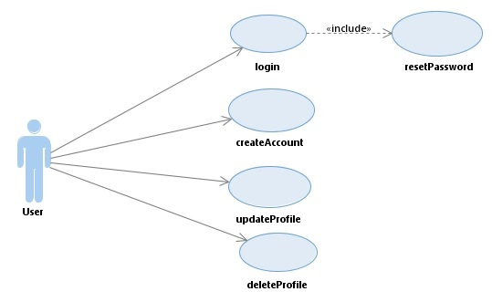

## 1: User Use Case Diagram

**Author:** Vamsi Charan Adari **Date:** 09/11/2018

## 1.1: Create Account

|  |  |  |  |
| --- | --- | --- | --- |
| Use case name: | Create account | | |
|  |  |  |  |
| Scenario: | User is willing to register an account. | | |
|  |  |  |  |
| Triggering Event: | Customer wants to set up account online | | |
| Brief Description: | User registers online by entering basic information, credit or debit card information, email address etc. | | |
| Actors: | User | | |
| Related use cases: | It can be used by any users to create their profile | | |
| Stakeholders: | Accounting, Sales | | |
| Preconditions: | User account subsystem should be available | | |
| Postconditions: | User is created and should be saved.  Addresses must be created by the user and saved. | | |
| Flow of activities: | |  |  | | --- | --- | | Actor | System | | 1. Starts the application process 2. Enter basic information | 1. Displays the registration screen 2. Stores the basic information of the user and   system associates User, account and address. | | | |
| Exception conditionals: | 1.1 The details provided by the customer will be displayed as incorrect.  2.1 System displays that the user is cannot be registered. | | |

**Author:** Vamsi Charan Adari **Date:** 09/11/2018

**CREATE ACCOUNT**

O **EMPLOYEE** O **MANAGER** O **CUSTOMER**

O **MALE** O **FEMALE**

**LAST NAME**

**FIRST NAME**

**MIDDLE NAME**

**ADDRESS1**

**ADDRESS 2**

**PIN**

**COUNTRY**

**PHONE**

**EMAIL**

**PASSWORD**

**CONFIRM PASSWORD**

**SUBMIT**

**RESET**

**1.1.2. Create Account**

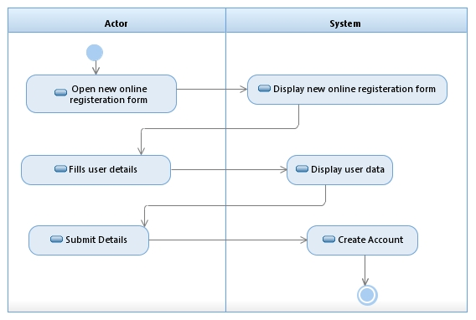

* + - 1. **Create Account Activity Diagram**

**Author:** Vamsi Charan Adari **Date:** 09/11/2018

## 1.2: Login

|  |  |  |  |
| --- | --- | --- | --- |
| Use case name: | Login | | |
|  |  |  |  | |
| Scenario: | Customer or the employee logs in to the account using valid credentials. | | |
|  |  |  |  | |
| Triggering Event: | Customer or the employee are logged in to their account successfully. | | |
| Brief Description: | The use case here explains about how the customer or the employee are logged in to their account using basic information such as user id, password, emailed etc. | | |
| Actors: | Customer and Employee | | |
| Related use cases: | Can be used by the users to login the account | | |
| Stakeholders: | Marketing, Sales | | |
| Preconditions: | Customer must have an online account. | | |
| Postconditions: | Customer or the employee are logged in to their account successfully. | | |
| Flow of activities: | |  |  | | --- | --- | | Actor | System | | 1.Logs in the account. | 1.System checks whether the user has valid account or not. | | | |
| Exception conditionals: | 1.1 Login failed.  2.1 Invalid user name or password. | | |

# 

**LOGIN PAGE**

**USERNAME**

**PASSWORD**

**LOGIN**

Forgot Password?

## 1.2.2. Login Screen

**Author:** Vamsi Charan Adari **Date:** 09/11/2018

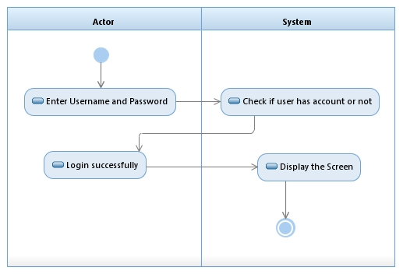

**1.2.2.2. Login Activity Diagram**

**Author:** Vamsi Charan Adari **Date:** 09/11/2018

## 1.3: Update profile

|  |  |  |  |
| --- | --- | --- | --- |
| Use case name: | Update Profile | | |
|  |  |  |  | |
| Scenario: | User wants to update the personal profile. | | |
|  |  |  |  | |
| Triggering Event: | User wishes to update the personal detail(s). | | |
| Brief Description: | User has the desire to update the profile. | | |
| Actors: | User, System | | |
| Related use cases: | View Profile | | |
| Stakeholders: | Marketing, Sales | | |
| Preconditions: | 1. User has an account.  2. User must be logged in. | | |
| Postconditions: | User is able to update the details. | | |
| Flow of activities: | |  |  | | --- | --- | | Actor | System | | 1. Actor accesses system to view page with personal details. 2. Selects edit option to edit details and enters new details to update. | 1. System displays the personal details page. 2. Saves new details entered by user. 3. Displays page with updated details. | | | |
| Exception conditionals: | * 1. User is not able to login. | | |

**UPDATE ACCOUNT**

O **EMPLOYEE** O **MANAGER** O **CUSTOMER**

O **MALE** O **FEMALE**

**LAST NAME EDIT**

**FIRST NAME EDIT**

**MIDDLE NAME EDIT**

**ADDRESS1 EDIT**

**ADDRESS 2 EDIT**

**PIN EDIT**

**COUNTRY EDIT**

**PHONE EDIT**

**EMAIL**

**PASSWORD**

**CONFIRM PASSWORD**

**RESET**

**UPDATE**

**4.1.1: Update Employee Information**

**1.3.3. Update Screen**

**Author:** Vamsi Charan Adari **Date:** 09/11/2018

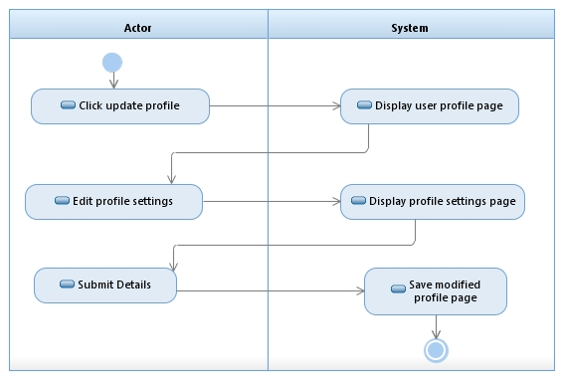

## 1.3.3.3 Update Profile Activity Diagram

**Author:** Vamsi Charan Adari **Date:** 09/11/2018

## 1.4: Reset Password

|  |  |  |  |
| --- | --- | --- | --- |
| Use case name: | Reset Password | | |
|  |  |  |  |
| Scenario: | Reset password using the email validation. | | |
|  |  |  |  |
| Triggering Event: | User requests to reset the password. | | |
| Brief Description: | User has forgotten or wishes to change their password. He/ she is directed to given email associated with the account and then asked to respond to the email sent by the system. | | |
| Actors: | User, System | | |
| Related use cases: | Create Account | | |
| Stakeholders: | Marketing, Sales | | |
| Preconditions: | 1. User has an account.  2. User should know the email associated with the account. | | |
| Postconditions: | User now has the new password according to his/her wish and he can login to the website with the new account. | | |
| Flow of activities: | |  |  | | --- | --- | | Actor | System | | 1. Access system to reset the account password. 2. Fills in email address 3. Follows redirect link to   password change page and proceeds to create and verify the password. | 1. Prompts actor to give a valid email address. 2. System checks if email is registered with an account, sends email with redirect link. 3. Checks the new passwords match and is unique from the previous one, returns user to the page previous for requesting the password reset. | | | |
| Exception conditionals: | * 1. Email address is not associated with an account.   2. Passwords do not match.   3. Password has met the required specifications. | | |



## 1.4.4. Reset Password

**Author:** Vamsi Charan Adari **Date:** 09/11/2018

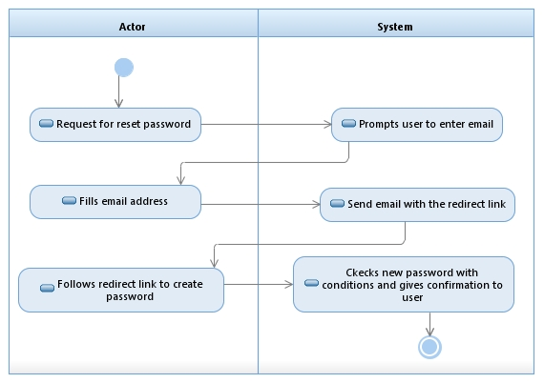

## 1.4.4.4. Reset Password Activity Diagram

**Author:** Vamsi Charan Adari **Date:** 09/11/2018

## 1.5: Delete profile

|  |  |  |  |
| --- | --- | --- | --- |
| Use case name: | Delete Profile | | |
|  |  |  |  | |
| Scenario: | User wants to delete the personal profile. | | |
|  |  |  |  | |
| Triggering Event: | User wishes to delete personal detail(s). | | |
| Brief Description: | User has the desire to delete the profile. | | |
| Actors: | User, System | | |
| Related use cases: | Update Profile | | |
| Stakeholders: | Marketing, Sales | | |
| Preconditions: | 1. User has an account.  2. User must be logged in. | | |
| Postconditions: | User had deleted profile. | | |
| Flow of activities: | |  |  | | --- | --- | | Actor | System | | 1. Actor clicks on delete button. | 1. System displays the message that profile has been deleted and delete all records of user. | | | |
| Exception conditionals: | * 1. User is not able to login. | | |

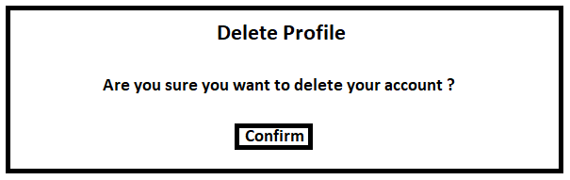

## 1.5.4. Delete Profile

**Author:** Vamsi Charan Adari **Date:** 09/11/2018

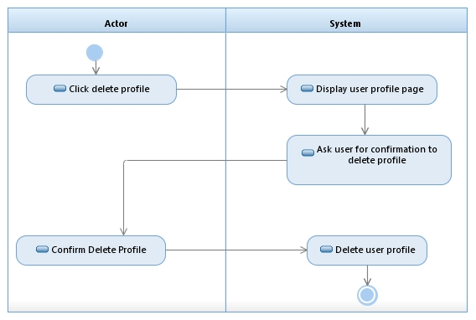

## 1.5.4.4. Delete Profile Activity Diagram

**Author:** Vamsi Charan Adari **Date:** 09/11/2018

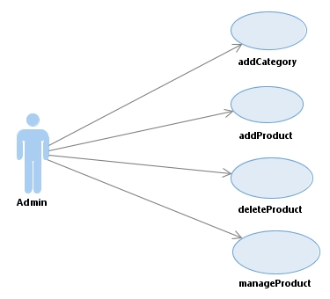

## 2: Admin Use Case Diagram

**Author:** Vamsi Charan Adari **Date:** 09/11/2018

|  |  |  |  |
| --- | --- | --- | --- |
| Use case name: | Add Category | | |
|  |  |  |  | |
| Scenario: | Admin wants to add category in system. | | |
|  |  |  |  | |
| Triggering Event: | Admin adds category. | | |
| Brief Description: | The use case shows how admin add category to the system. | | |
| Actors: | Admin | | |
| Related use cases: |  | | |
| Stakeholders: | Marketing, Sales | | |
| Preconditions: | Admin has successfully logged in system where he wants to add category. | | |
| Postconditions: | Category has been added successfully. | | |
| Flow of activities: | |  |  | | --- | --- | | Actor | System | | 1. Add new category. 2. Input type of category. | 1. Display page to add category. 2. Add category. | | | |
| Exception conditionals: | * 1. Admin cannot logged in system. | | |

## 2.1: Add Category

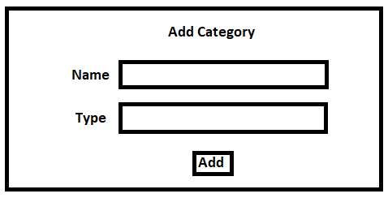

## 2.1. Add Category

**Author:** Vamsi Charan Adari **Date:** 09/11/2018

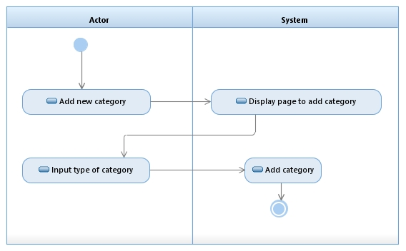

## 2.1.1. Add Category Activity Diagram

**Author:** Vamsi Charan Adari **Date:** 09/11/2018

|  |  |  |  |
| --- | --- | --- | --- |
| Use case name: | Add Product | | |
|  |  |  |  | |
| Scenario: | Admin wants to add product in system. | | |
|  |  |  |  | |
| Triggering Event: | Admin adds product. | | |
| Brief Description: | The use case shows how admin add product to the system. | | |
| Actors: | Admin | | |
| Related use cases: |  | | |
| Stakeholders: | Marketing, Sales | | |
| Preconditions: | Admin has successfully logged in system where he wants to add product. | | |
| Postconditions: | Product has been added successfully. | | |
| Flow of activities: | |  |  | | --- | --- | | Actor | System | | 1. Add new product. 2. Input type of category. | 1. Display page to add product. 2. Add product under given category. | | | |
| Exception conditionals: | * 1. Admin cannot log in system. | | |

## 2.2: Add Product

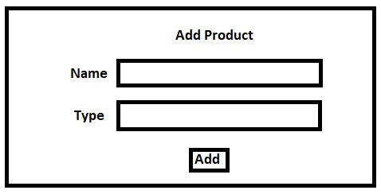

## 2.2. Add Product

**Author:** Vamsi Charan Adari **Date:** 09/11/2018

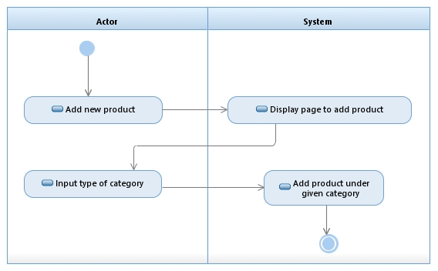

## 2.2.2. Add Product Activity Diagram

**Author:** Vamsi Charan Adari **Date:** 09/11/2018

|  |  |  |  |
| --- | --- | --- | --- |
| Use case name: | Manage Product | | |
|  |  |  |  | |
| Scenario: | Admin wants to manage product in system. | | |
|  |  |  |  | |
| Triggering Event: | Admin manages product. | | |
| Brief Description: | The use case shows how admin manage product to the system. | | |
| Actors: | Admin | | |
| Related use cases: |  | | |
| Stakeholders: | Marketing, Sales | | |
| Preconditions: | Admin has successfully logged in system where he wants to manage product. | | |
| Postconditions: | Product has been managed successfully. | | |
| Flow of activities: | |  |  | | --- | --- | | Actor | System | | 1. Manage product. 2. Edit details of the product. | 1. Display page to edit product details. 2. View modified product details. | | | |
| Exception conditionals: | * 1. Admin cannot log in system. | | |

## 2.3: Manage Product

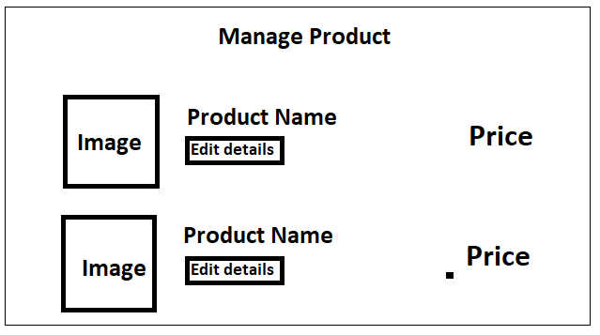

## 2.3. Manage Product Activity Diagram

**Author:** Vamsi Charan Adari **Date:** 09/11/2018

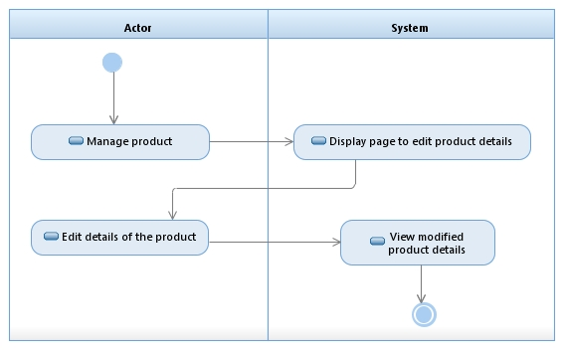

## 2.3.3. Manage Product Activity Diagram

**Author:** Vamsi Charan Adari **Date:** 09/11/2018

|  |  |  |  |
| --- | --- | --- | --- |
| Use case name: | Delete Product | | |
|  |  |  |  | |
| Scenario: | Admin wants to delete product in system. | | |
|  |  |  |  | |
| Triggering Event: | Admin deletes product. | | |
| Brief Description: | The use case shows how admin delete product to the system. | | |
| Actors: | Admin | | |
| Related use cases: |  | | |
| Stakeholders: | Marketing, Sales | | |
| Preconditions: | Admin has successfully logged in system where he wants to delete product. | | |
| Postconditions: | Product has been deleted successfully. | | |
| Flow of activities: | |  |  | | --- | --- | | Actor | System | | 1. Select product to delete. 2. Confirm delete product. | 1. Display product and option to delete. 2. Ask admin for confirmation to delete. 3. Delete product. | | | |
| Exception conditionals: | * 1. Admin cannot log in system. | | |

## 2.4: Delete Product

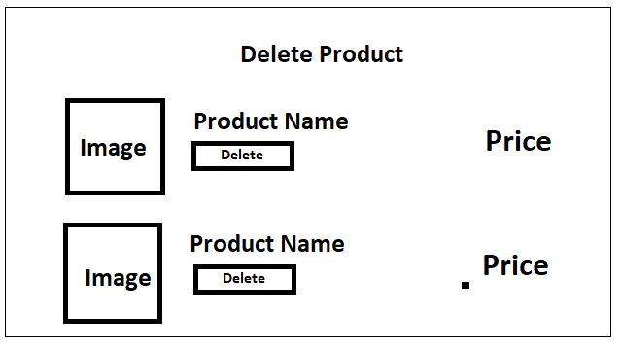

## 2.4. Delete Product Activity Diagram

**Author:** Vamsi Charan Adari **Date:** 09/11/2018

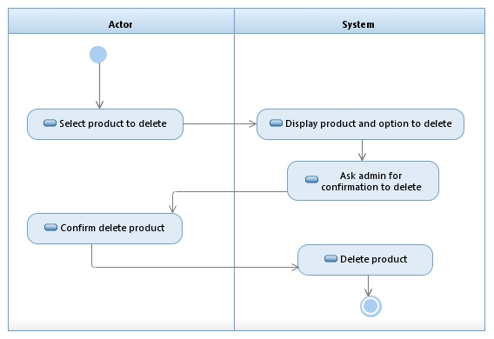

## 2.4.4. Delete Product Activity Diagram

**Author:** Vamsi Charan Adari **Date:** 09/11/2018

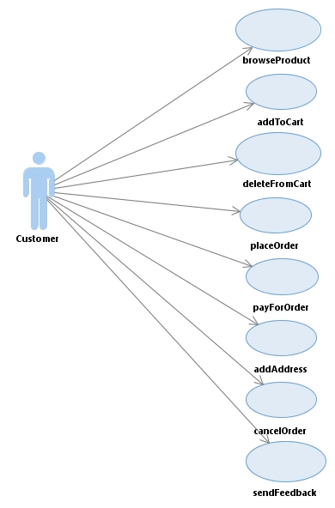

## 3: Customer Use Case Diagram

**Author:** Vamsi Charan Adari **Date:** 09/11/2018

|  |  |  |  |
| --- | --- | --- | --- |
| Use case name: | Browse Product | | |
|  |  |  |  | |
| Scenario: | Customer looks for the required product. | | |
|  |  |  |  | |
| Triggering Event: | Customer searches for the desired product which he wishes to purchase. | | |
| Brief Description: | Customer browses for the product according to the requirements. | | |
| Actors: | Customer | | |
| Related use cases: | Can be used by Customers to search item | | |
| Stakeholders: | Marketing, Sales | | |
| Preconditions: | 1.A Customer searching for a product.  2.The product that the Customer wishes to purchase. | | |
| Postconditions: | The Customer finds the product that he was looking for. | | |
| Flow of activities: | |  |  | | --- | --- | | Actor | System | | 1. Search for an item 2. Chooses according to what he is looking for. 3. Looks for the product according to the requirements. | 1. The System prompts requirements. 2. The System takes the requirements. 3. The System displays all related items. | | | |
| Exception conditionals: | * 1. No items found. | | |

## 3.1: Browse Product

**SEARCH**

**or**

**SEARCH BY ITEM ID**

**BROWSE PRODUCT**

**DEPARTMENT**

**ITEM NAME**

## 3.1.1. Browse Product

**Author:** Vamsi Charan Adari **Date:** 09/11/2018

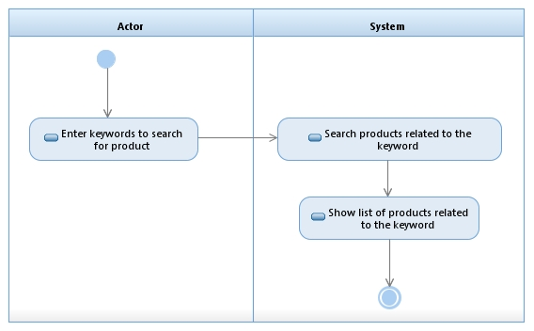

**3.1.1.1. Browse Product Activity Diagram**

**Author:** Vamsi Charan Adari **Date:** 09/11/2018

|  |  |  |  |  |
| --- | --- | --- | --- | --- |
| Use case name: | Add to Cart | | | |
|  |  |  |  |
| Scenario: | User wants to add product in cart. | | | |
|  |  |  |  |
| Triggering Event: | User should purchase an item online. | | | |
| Brief Description: | The use case shows how an item can be added to the cart. | | | |
| Actors: | User, System | | | |
| Related use cases: | Add Address | | | |
| Stakeholders: | Marketing, Sales | | | |
| Preconditions: | The list shows all the items selected. | | | |
| Postconditions: | Item is added to the cart successfully. | | | |
| Flow of activities: | |  |  | | --- | --- | | Actor | System | | 1. Select product to add. 2. Add product to cart. | * 1. Show option to add to cart.   2. Add selected product to cart. | | | | |
| Exception conditionals: | * 1. Item cannot be added to the cart. | | | |

## 3.2: Add to Cart

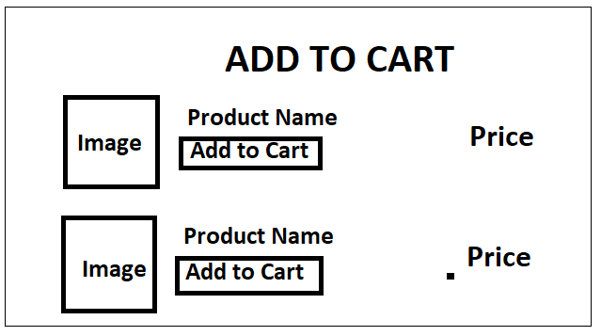

## 3.2. Add Product Activity Diagram

**Author:** Vamsi Charan Adari **Date:** 09/11/2018

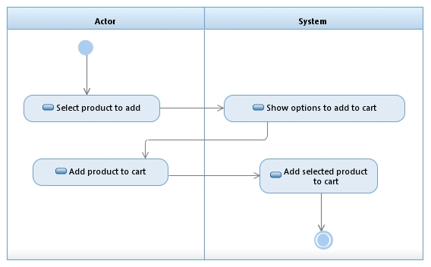

## 3.2.2. Add Product Activity Diagram

**Author:** Vamsi Charan Adari **Date:** 09/11/2018

|  |  |  |  |
| --- | --- | --- | --- |
| Use case name: | Cancel order | | |
|  |  |  |  |
| Scenario: | User wants to cancel the order | | |
|  |  |  |  |
| Triggering Event: | User wishes to purchase an item that is not available. | | |
| Brief Description: | The use case shows how an order can be cancelled. | | |
| Actors: | User | | |
| Related use cases: | Delete from Cart | | |
| Stakeholders: | Marketing, Sales | | |
| Preconditions: | Item should be available in the inventory. | | |
| Postconditions: | Item is deleted from the inventory. | | |
| Flow of activities: | |  |  | | --- | --- | | Actor | System | | 1. Select cancel button. 2. Select product to cancel order. | 1. Shows list of products ordered. 2. Cancel order and return payment to order. | | | |
| Exception conditionals: | * 1. The system displays as the order cannot be cancelled. | | |

## 3.3: Cancel Order

**CANCEL ORDER**

**SHIPPING NAME**

**SHIPPING ADDRESS**

**PHONE NUMBER**

|  |  |  |  |  |
| --- | --- | --- | --- | --- |
| **Product Code** | **Description** | **Quantity** | **Price per One** | **Total Price** |
|  |  |  |  |  |
|  | **CREDIT CARD NUMBER** |  |  |  |
|  |  |  |  |  |
| **ORDER ID** |  |  |  |  |
|  |  |  |  |  |

**CANCEL**

**ORDER**

**3.2.2 Cancel Order**

**Author:** Vamsi Charan Adari **Date:** 09/11/2018

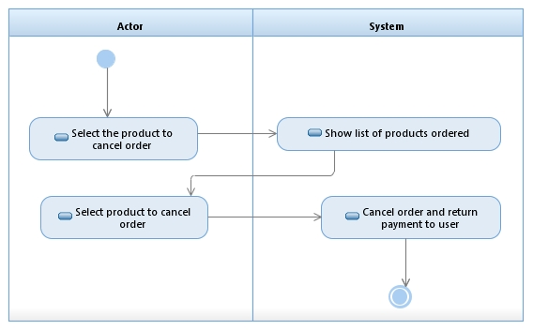

## 3.2.2.2. Delete Product Activity Diagram

**Author:** Vamsi Charan Adari **Date:** 09/11/2018

|  |  |  |  |
| --- | --- | --- | --- |
| Use case name: | Place an order | | |
|  |  |  |  | |
| Scenario: | User purchases an item. | | |
|  |  |  |  | |
| Triggering Event: | User finds the item according to his choice. | | |
| Brief Description: | User places the order. | | |
| Actors: | User | | |
| Related use cases: | Cancel Order | | |
| Stakeholders: | Marketing, Sales | | |
| Preconditions: | User selects the item. | | |
| Postconditions: | User uses the card information. | | |
| Flow of activities: | |  |  | | --- | --- | | Actor | System | | 1. Select place order to confirm details. 2. Confirm to place order. | 1. Asks for the confirmation to place order. 2. Order confirmed and proceed to payment. | | | |
| Exception conditionals: | * 1. No items in cart to place order. | | |

## 3.4: Place Order

**PLACE ORDER**

**SHIPPING NAME**

**SHIPPING ADDRESS**

**PHONE NUMBER**

|  |  |  |  |  |
| --- | --- | --- | --- | --- |
| **Product Code** | **Description** | **Quantity** | **Price per One** | **Total Price** |
|  |  |  |  |  |
|  | **CREDIT CARD NUMBER** |  |  |  |
|  |  |  |  | **Subtotal**  **Tax**  **Total** |
| **ORDER ID** |  |  |  |  |
|  |  |  |  |  |

HAVE ANY PROMO CODE? **ENTER HERE**

**CANCEL**

**ORDER**

## 3.3.3. Place Order

**Author:** Vamsi Charan Adari **Date:** 09/11/2018

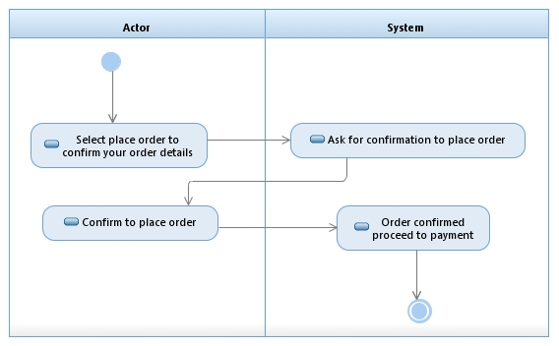

**3.3.3.3. Place Order Activity Diagram**

**Author:** Vamsi Charan Adari **Date:** 09/11/2018

|  |  |  |  |  |
| --- | --- | --- | --- | --- |
| Use case name: | Delete from Cart | | | |
|  |  |  |  |
| Scenario: | Customer wants to delete the products from cart. | | | |
|  |  |  |  |
| Triggering Event: | Customer wishes to delete the items which he doesn’t want. | | | |
| Brief Description: | Customer see the all products available in cart and delete the product which he doesn’t want to order. | | | |
| Actors: | Customer | | | |
| Related use cases: | Cancel Order | | | |
| Stakeholders: | Marketing, Sales | | | |
| Preconditions: | Items should be available in inventory. | | | |
| Postconditions: | Items are deleted from the inventory. | | | |
| Flow of activities: | |  |  | | --- | --- | | Actor | System | | 1. Select product to delete from cart. 2. Choose remove to remove products from cart. | 1. Show list of products added in cart. 2. Remove selected products from cart. | | | | |
| Exception conditionals: | * 1. System displays products that cannot be deleted. | | | |

## 3.3: Delete from Cart

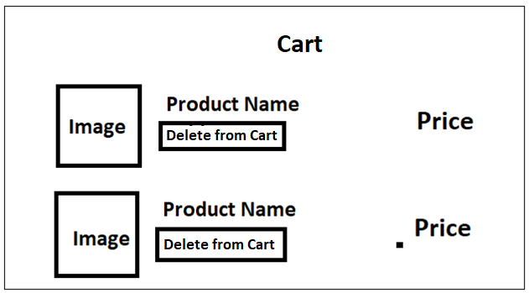

## 3.4. Delete from Cart Activity Diagram

**Author:** Vamsi Charan Adari **Date:** 09/11/2018

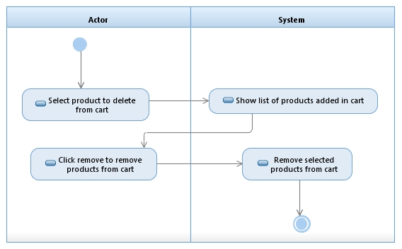

## 3.4.4. Delete from Cart Activity Diagram

**Author:** Vamsi Charan Adari **Date:** 09/11/2018

|  |  |  |  |
| --- | --- | --- | --- |
| Use case name: | Pay for Order | | |
|  |  |  |  | |
| Scenario: | User requests to make payment | | |
|  |  |  |  | |
| Triggering Event: | User confirms to purchase the item. | | |
| Brief Description: | The payment is done using the credit/debit card information saved in the account. | | |
| Actors: | User | | |
| Related use cases: |  | | |
| Stakeholders: | Marketing, Sales | | |
| Preconditions: | Item should be added in the cart. | | |
| Postconditions: | All the details entered should be correct. | | |
| Flow of activities: | |  |  | | --- | --- | | Actor | System | | 1. Pay for the order to checkout order. 2. Select one payment method to pay for the order. | 1. Show list of payment options available to user. 2. Complete payment and checkout. | | | |
| Exception conditionals: | * 1. Card information entered is invalid.   2. Incorrect address. | | |

**3.5: Pay for Order**

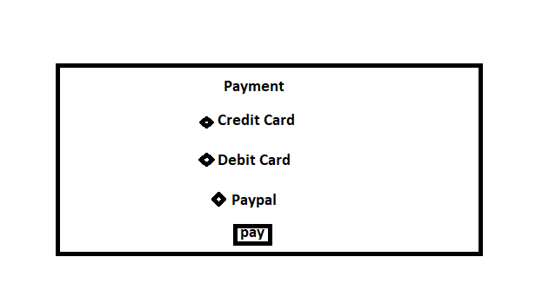

## 3.5 Pay for Order Activity Diagram

**Author:** Vamsi Charan Adari **Date:** 09/11/2018

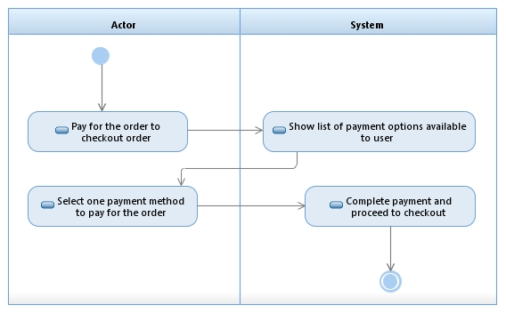

## 3.5.5 Pay for Order Activity Diagram

**Author:** Vamsi Charan Adari **Date:** 09/11/2018

## 3.6: Add Address

|  |  |  |  |
| --- | --- | --- | --- |
| Use case name: | Add address | | |
|  |  |  |  | |
| Scenario: | User must add the shipping address for the delivery of items | | |
|  |  |  |  | |
| Triggering Event: | User wants the item to be shipped to the desired address | | |
| Brief Description: | User needs to add the new shipping address for the items to be delivered | | |
| Actors: | User | | |
| Related use cases: | Add Product | | |
| Stakeholders: | Marketing, Sales | | |
| Preconditions: | User needs to buy an item to be shipped and the address should be the valid address | | |
| Postconditions: | Item is delivered to the given shipping address | | |
| Flows of activities: | |  |  | | --- | --- | | Actor | System | | 1. Click on ‘add address’. | 1. 1.1 Display text field to upload address. | | 1. Add address to profile. | 2. 2.2 Upload address to profile for shipment | | | |
| Exception conditionals: | Items will not be delivered to invalid address | | |

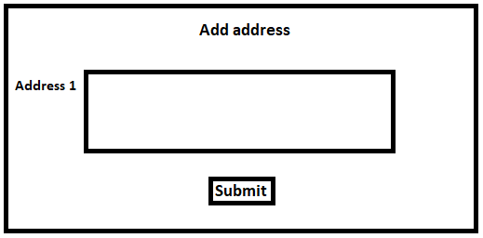

## 3.6. Add Address Activity Diagram

**Author:** Vamsi Charan Adari **Date:** 09/11/2018

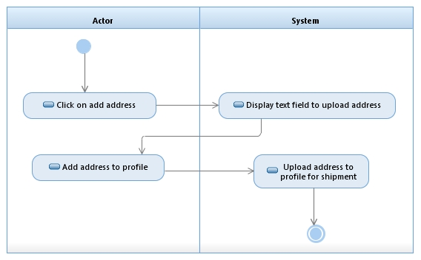

## 3.6.6. Add Address Activity Diagram

**Author:** Vamsi Charan Adari **Date:** 09/11/2018

**3.8: Send feedback**

|  |  |  |  |
| --- | --- | --- | --- |
| Use case name: | Send feedback | | |
|  |  |  |  | |
| Scenario: | User views or provides the feedback of the products | | |
|  |  |  |  | |
| Triggering Event: | User tries to give the feedback associated with the item. | | |
| Brief Description: | User provides feedback. | | |
| Actors: | User | | |
| Related use cases: |  | | |
| Stakeholders: | Marketing, Sales | | |
| Preconditions: | User should be navigated to the feedback page where there will be a dialogue box in which he should be able to type his comments or user should be able to select the number on the feedback scale. | | |
| Postconditions: | User should receive the success message from the seller that the user review has been received. | | |
| Flow of activities: | |  |  | | --- | --- | | Actor | System | | 1. Gives feedback to the ordered product. | 1. 1.1 Show feedback text field to take feedback of the product | | 1. Enter the feedback to the product. | 1. 2.1 Submit feedback for the ordered product | | | |
| Exception conditionals: | 1.Invalid webpage  2.Submission failed | | |

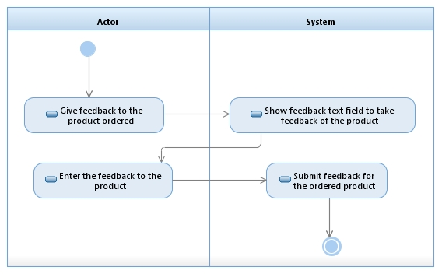

## 3.7.7. Send Feedback Activity Diagram

**Author:** Vamsi Charan Adari **Date:** 09/11/2018

**SEND FEEDBACK**

**Enter the Text**

**EMAIL ID**

**CLEAR**

**SUBMIT**

## 3.7.7.7. Send Feedback

**Author:** Vamsi Charan Adari **Date:** 09/11/2018

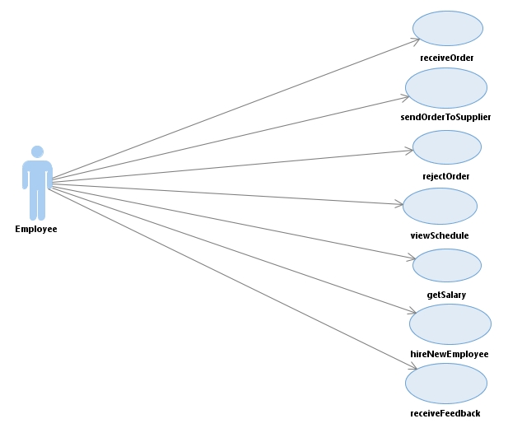

**4: Employee Use Case Diagram**

**Author:** Vamsi Charan Adari **Date:** 09/11/2018

|  |  |  |  |  |
| --- | --- | --- | --- | --- |
| Use case name: | Receive order | | | |
|  |  |  |  |
| Scenario: | Employee receives the order | | | |
|  |  |  |  |
| Triggering Event: | Employee receives the order which is requested by customer. | | | |
| Brief Description: | Employee receives the order which is requested by customer and request to the supplier. | | | |
| Actors: | Employee, Customer | | | |
| Related use cases: | Add order | | | |
| Stakeholders: | Marketing, Sales | | | |
| Preconditions: | Item should be available in the inventory. | | | |
| Postconditions: | Employee sends order to the supplier. | | | |
| Flow of activities: | |  |  | | --- | --- | | Actor | System | | 1. Receive order from customers. 2. Approve orders for shipment. | 1. Get the details of the customers ordering products. 2. Show verifications to users for shipment for orders. | | | | |
| Exception conditionals: | * 1. The system doesn’t give the information about customers. | | | |

## 4.1: Receive Order

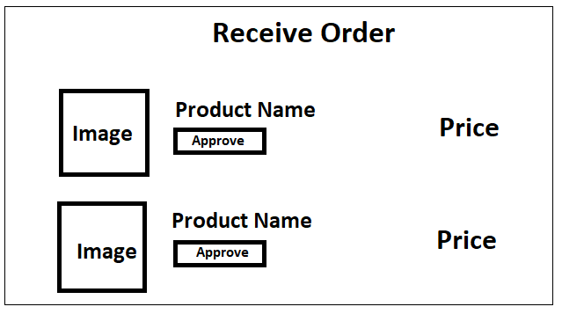

## Receive Order Activity Diagram

**Author:** Vamsi Charan Adari **Date:** 09/11/2018

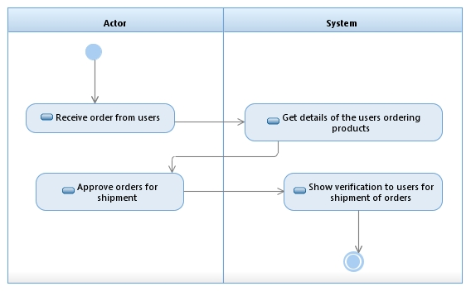

## Receive Order Activity Diagram

1. **Author:** Vamsi Charan Adari **Date:** 09/11/2018

## 5.1: Receive Feedback

|  |  |  |  |
| --- | --- | --- | --- |
| Use case name: | Receive Feedback | | |
|  |  |  |  | |
| Scenario: | Employee views the feedback which are given by customers. | | |
|  |  |  |  | |
| Triggering Event: | System should display the feedbacks from customers. | | |
| Brief Description: | This use case describes how employee get the feedback from customers. | | |
| Actors: | Employee, Customers | | |
| Related use cases: |  | | |
| Stakeholders: | Marketing, Sales | | |
| Preconditions: | There are feedbacks from customers. | | |
| Postconditions: | Employee receives the feedback from customers. | | |
| Flows of activities: | |  |  | | --- | --- | | Actor | System | | 1. Request to get the feedback from the users. | 1. Display feedbacks given by the users. | | 1. Receive feedback from the users. | . | | | |
| Exception conditionals: | There is no feedback to view. | | |

**RECEIVE FEEDBACK**

**Enter the Text**

**EMAIL ID**

**CLEAR**

**SUBMIT**

## 4.2. Receive Feedback Activity Diagram

**Author:** Vamsi Charan Adari **Date:** 09/11/2018

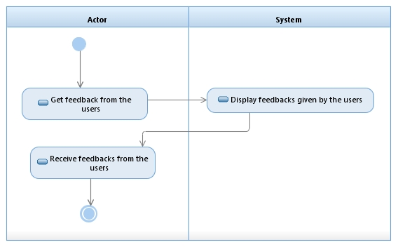

## 4.2.2. Receive Feedback Activity Diagram

**Author:** Vamsi Charan Adari **Date:** 09/11/2018

|  |  |  |  |  |
| --- | --- | --- | --- | --- |
| Use case name: | Send order to supplier | | | |
|  |  |  |  |
| Scenario: | Employee send orders to supplier. | | | |
|  |  |  |  |
| Triggering Event: | System gets the required orders from employee. | | | |
| Brief Description: | Employee send request to get required items to the supplier. | | | |
| Actors: | Employee, Supplier | | | |
| Related use cases: |  | | | |
| Stakeholders: | Marketing, Sales | | | |
| Preconditions: | Employee make list of required items. | | | |
| Postconditions: | Supplier gets the list of required order. | | | |
| Flow of activities: | |  |  | | --- | --- | | Actor | System | | 1. Request for the list of orders to be received from supplier. 2. Send required list of orders to supplier. | 1. Get the list of orders required from employee. | | | | |
| Exception conditionals: | * 1. No items to give order. | | | |

## 4.2: Send Order to Supplier

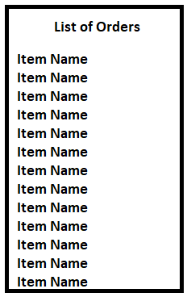

## 4.3. Send Order to Supplier Activity Diagram

**Author:** Vamsi Charan Adari **Date:** 09/11/2018

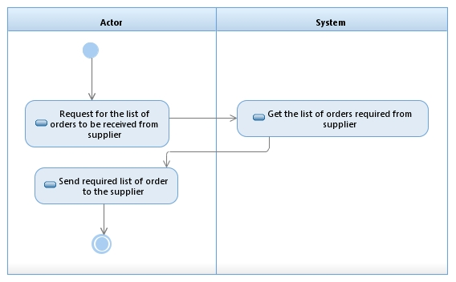

## 4.3.3. Send Order to Supplier Activity Diagram

**Author:** Vamsi Charan Adari **Date:** 09/11/2018

## 4.3: Reject Order

|  |  |  |  |  |
| --- | --- | --- | --- | --- |
| Use case name: | Reject order | | | |
|  |  |  |  |
| Scenario: | Employee reject orders which are not in stock. | | | |
|  |  |  |  |
| Triggering Event: | System gets the request for reject the order from employee. | | | |
| Brief Description: | Employee reject order which are not available in stock and send the message to the customer when it will be available. | | | |
| Actors: | Employee, Customer | | | |
| Related use cases: |  | | | |
| Stakeholders: | Marketing, Sales | | | |
| Preconditions: | Employee gets the order from customer | | | |
| Postconditions: | Employee deletes items which are not available in stock. | | | |
| Flow of activities: | |  |  | | --- | --- | | Actor | System | | 1. Get all the orders from users. 2. Cancel orders from users which are not available in stock. | 1. Display orders from all the users. 2. Send cancelled order receipt. | | | | |
| Exception conditionals: | * 1. No items in cart. | | | |

## \4.4. Reject Order Activity Diagram

**Author:** Vamsi Charan Adari **Date:** 09/11/2018

## 

## 4.4.4. Reject Order Activity Diagram

**Author:** Vamsi Charan Adari **Date:** 09/11/2018

**4.6: Hire New Employee**

|  |  |  |  |
| --- | --- | --- | --- |
| Use case name: | Hire New Employee | | |
|  |  |  |  | |
| Scenario: | New employee record is created | | |
|  |  |  |  | |
| Triggering Event: | New employee record is added to the employee list | | |
| Brief Description: | It checks about the employability status of the employee. | | |
| Actors: | Applicants,Employee | | |
| Related use cases: |  | | |
| Stakeholders: | Marketing, Sales | | |
| Preconditions: | Employee information should be updated in the system | | |
| Postconditions: | Applicant is now employee. | | |
| Flows of activities: | |  |  | | --- | --- | | Actor | System | | 1. Conduct interviews for the applicants who applied for job role, | 1. Save the record of applicants. | | 1. Hire new employees. |  | | | |
| Exception conditionals: | System fails to load the information. | | |

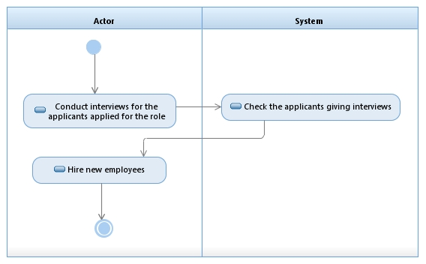

## 4.5.5. Hire New Employee Activity Diagram

**Author:** Vamsi Charan Adari **Date:** 09/11/2018

## 4.4 View Schedule

|  |  |  |  |
| --- | --- | --- | --- |
| Use case name: | View Schedule | | |
|  |  |  |  | |
| Scenario: | Employee views the changes in the employee schedule must be done | | |
|  |  |  |  | |
| Triggering Event: | System should display the updated employee schedule | | |
| Brief Description: | This use case describes how the manager creates the employee schedule and updates the changes | | |
| Actors: | Employee | | |
| Related use cases: |  | | |
| Stakeholders: | Marketing, Sales | | |
| Preconditions: | Employee record must be there. | | |
| Postconditions: | Employee view the updated schedule. | | |
| Flows of activities: | |  |  | | --- | --- | | Actor | System | | 1. Request schedule of the employees. | 1. Display the schedule of all employees. | | 1. View schedule of the employees. | . | | | |
| Exception conditionals: | Employee Schedule is not taken as input into the system. | | |

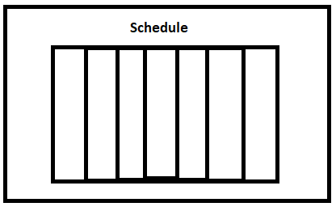

## 4.6. View Schedule Activity Diagram

**Author:** Vamsi Charan Adari **Date:** 09/11/2018

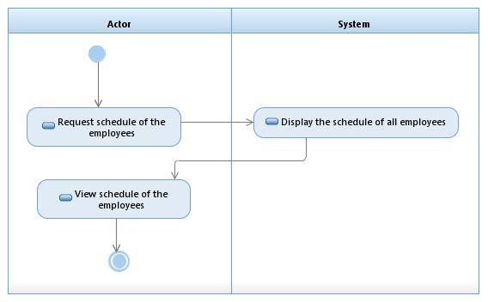

## 4.6.6. View Schedule Activity Diagram

**Author:** Vamsi Charan Adari **Date:** 09/11/2018

## 4.5: Get Salary

|  |  |  |  |  |
| --- | --- | --- | --- | --- |
| Use case name: | Get salary | | | |
|  |  |  |  |
| Scenario: | Employee gets salary from organization. | | | |
|  |  |  |  |
| Triggering Event: | Employee gives his bank account information to the system. | | | |
| Brief Description: | Employee gets salary on the registered bank account. | | | |
| Actors: | Employee | | | |
| Related use cases: |  | | | |
| Stakeholders: | Marketing, Sales | | | |
| Preconditions: | Employee gives the bank account | | | |
| Postconditions: | Employee gets the salary in bank account. | | | |
| Flow of activities: | |  |  | | --- | --- | | Actor | System | | 1. Get Salary for the worked hours. 2. Get payment for the worked hours. | 1. Approve payment for the worked hours. | | | | |
| Exception conditionals: | * 1. Give invalid bank account details. | | | |

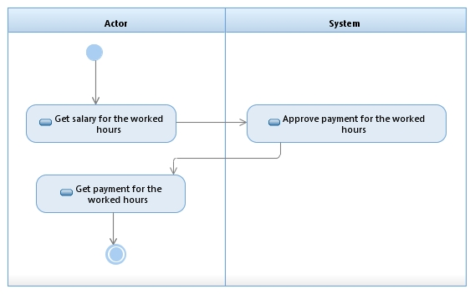

## 4.7.7. Get Salary Activity Diagram

**Author:** Vamsi Charan Adari **Date:** 09/11/2018

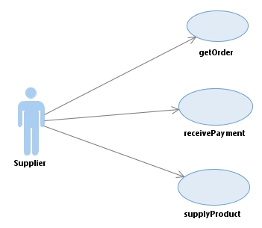

**5: Supplier Use Case Diagram**

**Author:** Vamsi Charan Adari **Date:** 09/11/2018

## 5.1: Get Order

|  |  |  |  |
| --- | --- | --- | --- |
| Use case name: | Get Order | | |
|  |  |  |  |
| Scenario: | Get order details to supply | | |
|  |  |  |  |
| Triggering Event: | Supplier gets order details from employee to supply. | | |
| Brief Description: | Supplier wants to get order details from employee to supply. | | |
| Actors: | Employee, Supplier | | |
| Related use cases: |  | | |
| Stakeholders: | Customer, Employee | | |
| Preconditions: | 1. Employee has order details. 2. Employee has verified that he doesn’t have items in stock. | | |
| Postconditions: | Supplier has order details. | | |
| Flows of activities: | |  |  | | --- | --- | | Actor | System | | 1. Get order details to supply. | 1. Order details from the employee. | | 1. Verify ordered products in stock and send availability. | 2. Receive availability status of order. | | | |
| Exception conditionals: | Employee doesn’t have order. | | |

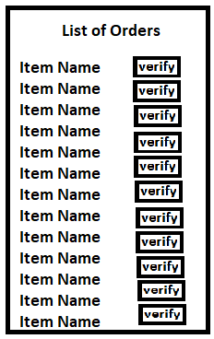

## 5.1. Get Order Activity Diagram

**Author:** Vamsi Charan Adari **Date:** 09/11/2018

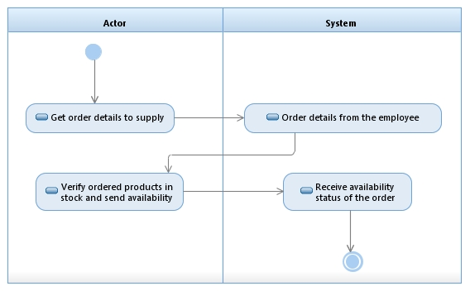

## 5.1.1. Get Order Activity Diagram

**Author:** Vamsi Charan Adari **Date:** 09/11/2018

## 5.2: Supply Product

|  |  |  |  |
| --- | --- | --- | --- |
| Use case name: | Supply Product. | | |
|  |  |  |  | |
| Scenario: | Supplier supplies product to employee. | | |
|  |  |  |  | |
| Triggering Event: | Supplier wants to supply product to employee. | | |
| Brief Description: | Supplier supplies the product to employee for which he/she ordered. | | |
| Actors: | Supplier | | |
| Related use cases: |  | | |
| Stakeholders: | Employee | | |
| Preconditions: | 1. Supplier has order details from employee. 2. Supplier has products in stock. | | |
| Postconditions: | Supplier supplies the product to employee. | | |
| Flows of activities: | |  |  | | --- | --- | | Actor | System | | 1. Get order details to supply product. | 1.Display order details. | | 1. Supply order to the system. | . | | | |
| Exception conditionals: | Supplier doesn’t have order details from employee. | | |

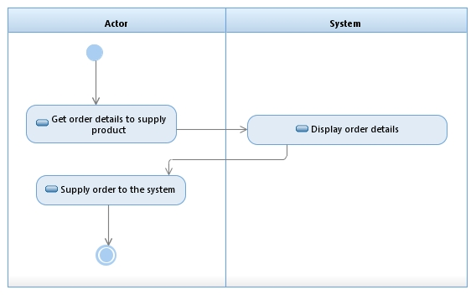

## 5.2.2. Supply Product Activity Diagram

**Author:** Vamsi Charan Adari **Date:** 09/11/2018

## 5.3: Receive Payment

|  |  |  |  |
| --- | --- | --- | --- |
| Use case name: | Receive payment | | |
|  |  |  |  | |
| Scenario: | Supplier receives payment. | | |
|  |  |  |  | |
| Triggering Event: | Supplier wants to receive payment for order. | | |
| Brief Description: | Supplier receives the payment from employee for the order he made. | | |
| Actors: | Employee, Supplier | | |
| Related use cases: |  | | |
| Stakeholders: | Employee | | |
| Preconditions: | 1. Employee has made order. 2. Supplier has the order details. 3. Supplier supplied the product. | | |
| Postconditions: | Supplier receives the payment for order. | | |
| Flows of activities: | |  |  | | --- | --- | | Actor | System | | 1. Request payment from employee. | 1. Release payment for the order made. | | 1. Receive payment for the order supplied. | . | | | |
| Exception conditionals: | Employee enters invalid card details. | | |

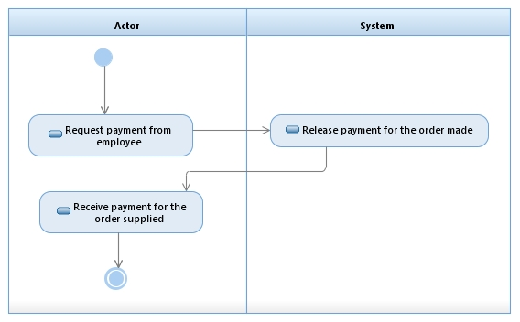

## 5.3.3. Receive Payment Activity Diagram

**Author:** Vamsi Charan Adari **Date:** 09/11/2018

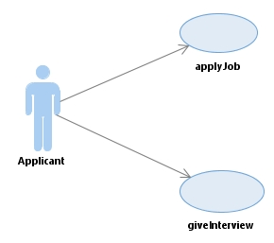

**6: Applicant Use Case Diagram**

**Author:** Vamsi Charan Adari **Date:** 09/11/2018

## 6.1: Apply for Job

|  |  |  |  |
| --- | --- | --- | --- |
| Use case name: | Apply for job. | | |
|  |  |  |  | |
| Scenario: | Applicant wants to apply for job role. | | |
|  |  |  |  | |
| Triggering Event: | Applicant get the interview details from the admin. | | |
| Brief Description: | Applicant wants to apply for job and send profile to the admin. | | |
| Actors: | Applicant | | |
| Related use cases: |  | | |
| Stakeholders: | Employee | | |
| Preconditions: | There are available jobs to apply. | | |
| Postconditions: | Applicant has applied for job. | | |
| Flows of activities: | |  |  | | --- | --- | | Actor | System | | 1. Apply for job role. | 1.Show list of available job roles. | | 1. Select job role to apply and send profile. | .  2.Apply for selected job role. | | | |
| Exception conditionals: | No job available for applying. | | |

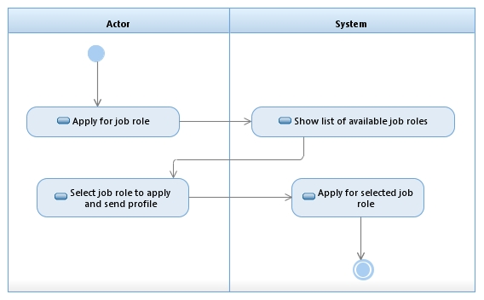

## 6.1.1. Apply Job Activity Diagram

**Author:** Vamsi Charan Adari **Date:** 09/11/2018

## 6.2: Give Interview

|  |  |  |  |
| --- | --- | --- | --- |
| Use case name: | Give Interview | | |
|  |  |  |  | |
| Scenario: | Applicant wants to give interview. | | |
|  |  |  |  | |
| Triggering Event: | Applicant get the interview details from the admin. | | |
| Brief Description: | Applicant wants to apply for job and send profile to the admin. | | |
| Actors: | Applicant | | |
| Related use cases: |  | | |
| Stakeholders: | Employee | | |
| Preconditions: | There are available jobs to apply. | | |
| Postconditions: | Applicant has applied for job. | | |
| Flows of activities: | |  |  | | --- | --- | | Actor | System | | 1. Attend interview for the job role. | 1.Conduct interview for the role. | | 1. Give details and profile. | .  2.Hire employee for the role. | | | |
| Exception conditionals: | No job available for applying. | | |

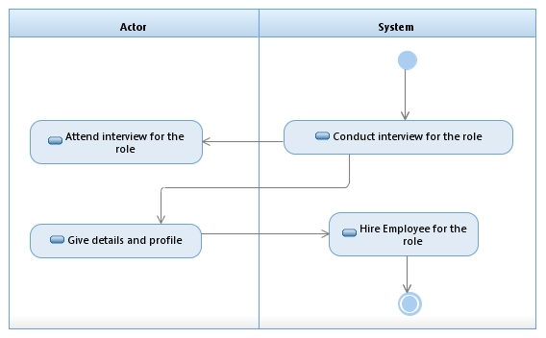

## 6.2.2. Give Interview Activity Diagram

**Author:** Vamsi Charan Adari **Date:** 09/11/2018

**7. STATE CHART DIAGRAM:**

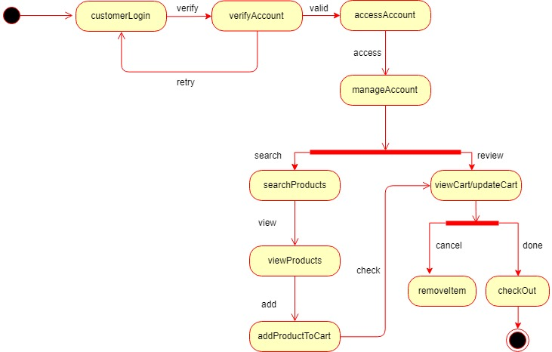

## 7. State Chart Diagram

**Author:** Vamsi Charan Adari **Date:** 09/11/2018

**8. DEPLOYMENT DIAGRAM:**

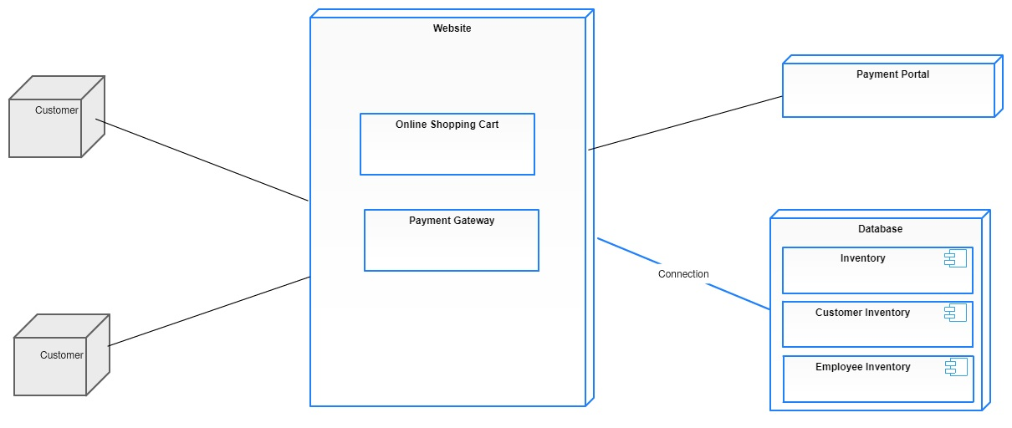

## 8. State Chart Diagram

**Author:** Vamsi Charan Adari **Date:** 09/11/2018

1. **DFD DESCRIPTION:**

**Online Store Management System**:

Online Store Management System is a web application which acts as a market

platform for both buyers and sellers. The main objective of the application is to

make direct selling from sellers to buyers without any storage or warehouse to

store the products.

**EXTERNAL ENTITIES:**

**ENTITY 1:**

**Customer:**

Customer is defined as a person or an organization that buys products or services

from an online store or business,

Customers are of two types:

1. Direct Customers- They are the ones who buy the commodities, or

the goods based on their daily basis directly from the store and who live in

the locality.

2. Indirect Customers- They are commonly known as the retailers who

buy the goods on bulk and sell them at prices higher than the cost price as

to gain profits.

**ENTITY2:**

**Employee:**

The people who are hired for the store are known as Employees. The employee is scheduled according to the preference and availability. A time card is generated for the employee. A pay check is given for the service provided by the employees.

**ENTITY3:**

**Supplier:**

A supplier is a person or an organization from whom the products or services are purchased by the Online Store Management System. The management places the invoice order to the supplier for goods and products.

**ENTITY4:**

**Applicant:**

An applicant is a person who submits an application to apply for job. On being hired, receives the job offer.

**DATA FLOW:**

**Order:**

Order is data flow from customer to the Management System. The operation of this data flow is when the customer places the order, the item order is processed and shipped to customer.

**Receipt:**

Receipt is data flow from the Management System to the customer. The operation of this data flow is a receipt is generated and delivered to the customer along with the shipment when the order is placed.

**Schedule Preference:**

Schedule preference is data flow where the employee is scheduled according to the preference and availability. The employee is scheduled and provides services.

**Pay Check:**

Pay Check is data flow from the Management System to the employee. The Management System pays the employee for the services provided by him.

**Sell Item:**

Sell Item is data flow from the Supplier to the Management System. It displays all the products and services that are available to sell and can that be accessed.

**Purchase Order:**

The management purchases the order from the supplier to the run the system.

**Application:**

Application is data flow from an applicant to the Management System. The applicant applies for the job by applying.

**Job Offer:**

Job Offer is data flow from the Management System to the applicant indicating that the applicant has been selected for the job.

**DATA STORE:**

**Item Master:**

Item master is a data store which has the item record. The orders placed for the items can be searched in this data store.

**Customer Master:**

Customer master is a data store which stores all the information of the customer. It contains the customer record which can be used for preparing the shipment statement on the name of the customer.

**Employee Master:**

Employee master is a data store which stores all the information of an employee. It contains the employee record which can be used to hire the employee, pay the employee.

**Inventory:**

Inventory is a data store where all the items are available. It can be used to buy the item, process the item order, service the item order, receive items.

**Payment Master:**

Payment Master is a data store which stores the payment ID, total price. It has payment method options for the customer.

**PROCESS:**

**ReceiveOrder:**

The process searches for products in inventory which are requested by customer for purchasing order. If products are available upon request, it will display the list of products, else it shows no result.

**ProcessOrder**:

The process searches for products in inventory which are requested by customer for purchasing order. If products are available upon request, it will display the list of products and place the order what he wants to buy, else it shows no result.

**ReceivePayment:**

The process receives payment from the customer and proceeds to place order.

**ShipOrder:**

The process searches customer master inventory to get correct details of the customer such as address, name to deliver the order which has been placed by the customer.

**GetItem:**

The process gets item from the supplier. An invoice is placed to get all the items from the supplier.

**ServiceOrder:**

The process services all the orders placed by the customers.

**HireEmployee:**

The process schedules the interview for employee and hire employee. After hiring employee, it schedules work hours and decides salary.

**PayEmployee:**

The employees hired are scheduled accordingly and pay check is given to the employee.

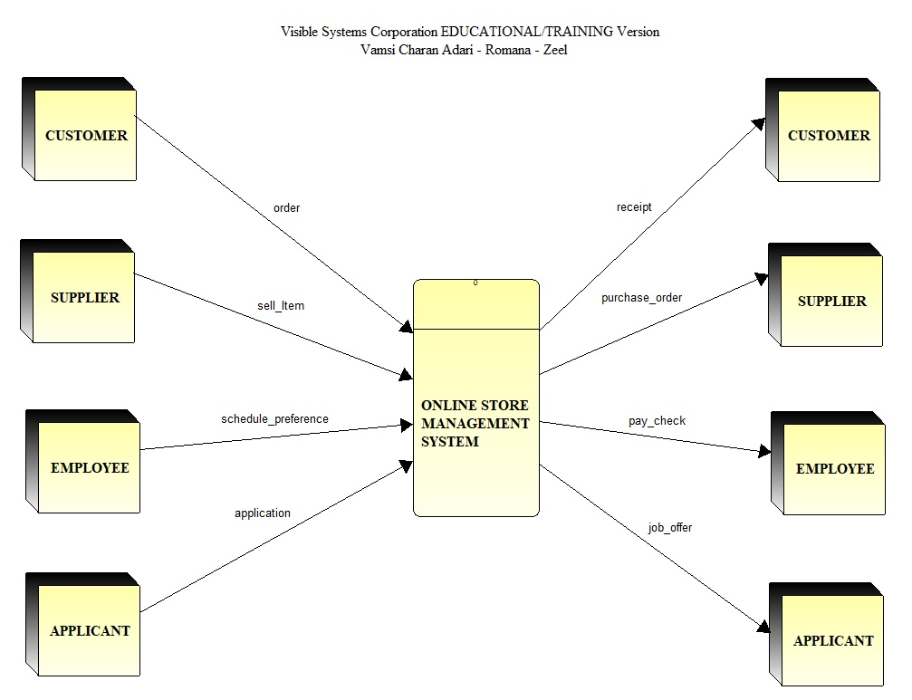

**8.1. Context Level Data Flow Diagram**

**Author:** Vamsi Charan Adari **Date:** 09/11/2018

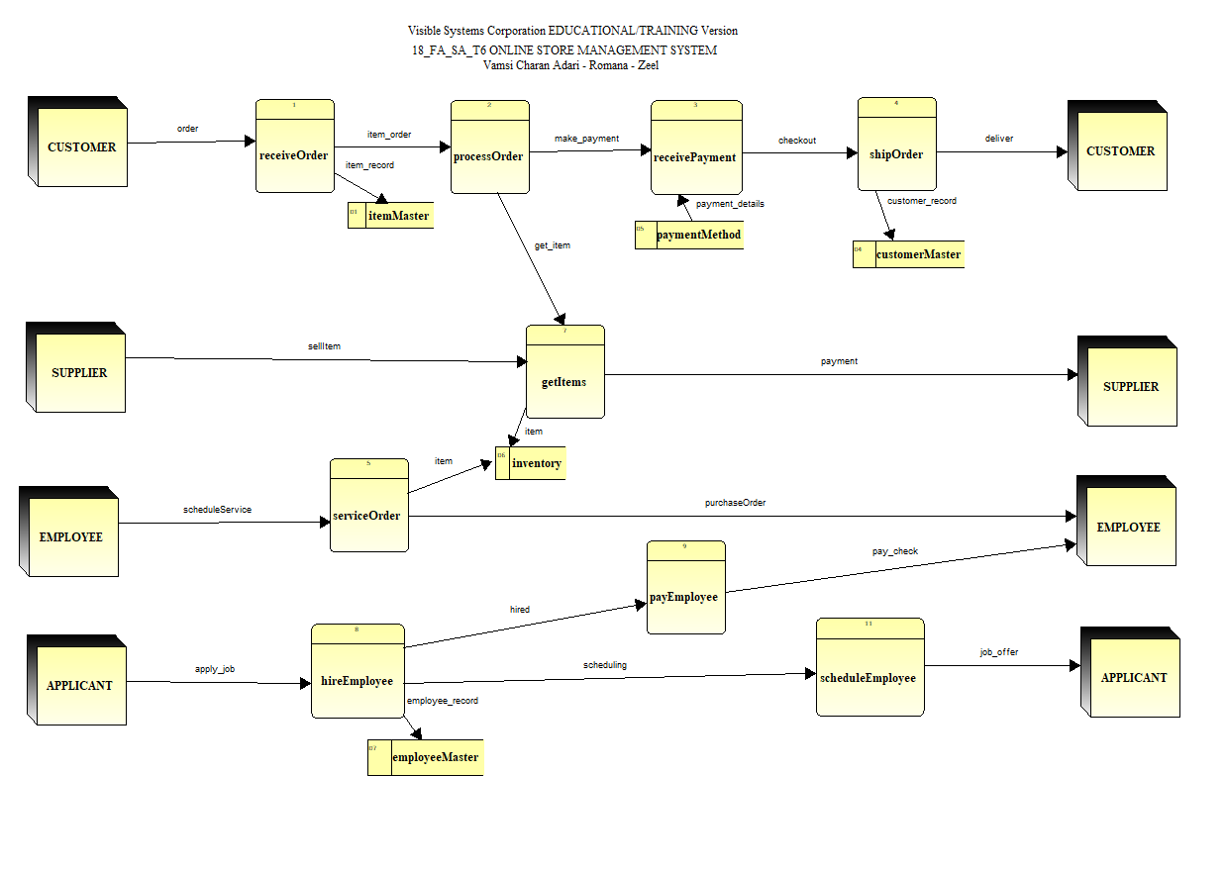

**8.2. Level 0 Data Flow Diagram**

**Author:** Vamsi Charan Adari **Date:** 09/11/2018

**Structured English :1**

**Author:** Vamsi Charan Adari **Date:** 09/11/2018

Input File: The customer order file

Output File: The customer receipt File.

A simple pseudocode for the **Customer** process is as follows:

GET Order Details

GET Customer Details

GET Feedback

DO format Customer Name (only one space between First/Middle/Last)

DO format Customer Address lines

DO WHILE there are products for the order

GET Product Record

DO Format Product Line

Move Amount to Order Total

ENDDO

Move Order Total to Shipping Statement

Move 0 to Tax

Multiply Order Total by Tax Rate giving Tax

Move Tax to Shipping Statement

DO calculate Shipping and Handling

Move Shipping and Handling to Shipping Statement

Add Order Total, Tax and Shipping and Handling giving Order Total

Move Order Total to Shipping Receipt

**Structured English :2**

**Author:** Vamsi Charan Adari **Date:** 09/11/2018

Input File: The supplier sells product file

Output File: The supplier purchase order File.

A simple pseudocode for the **Supplier** process is as follows:

GET Order Details

GET Customer Order Requirement

Move Order Number to Order List

Move Order Date to Order Date List

Move Customer Number to Order Enquiry

IF Order is equal to 0

SUBTRACT Order from Order List

ENDIF

DO format Customer Name (only one space between First/Middle/Last)

ENDDO

Move Order Details to Supplier Purchase Order

ADD Order Details, Quantity and Order Date giving Purchase Order Details

**Structured English :3**

**Author:** Vamsi Charan Adari **Date:** 09/11/2018

Input File: The employee schedule file

Output File: The employee pays File.

A simple pseudocode for the **Employee** process is as follows:

GET Employee Details

GET Employee Schedul0065

GET Employee Salary

GET Feedback

IF Employee Schedule is verified to Working Hours

ADD Pay Check to Employee Salary

ENDIF

DO format Employee Name (only one space between First/Middle/Last)

ENDDO

Move Employee Salary to Employee Pay Check

ADD Employee Details giving Employee Salary

**Structured English :4**

**Author:** Vamsi Charan Adari **Date:** 09/11/2018

Input File: The applicant file

Output File: The applicant job offers File.

A simple pseudocode for the **Applicant** process is as follows:

GET Applicant Details

GET Applicant Profile

Move Applicant Name to Job Interviews List

Move Applicant Number to Job Interviews List

Move Application Date to Job Interviews List

DO format Applicant Name (only one space between First/Middle/Last)

DO format Applicant Address lines

IF Applicant Profile matches to Job Role

ADD Applicant to Interview List

ENDIF

Add Applicant Details giving Job Offer

**Pseudo Code**

**Author:** Vamsi Charan Adari **Date:** 09/11/2018

Process Id: 1

Process Name: Receive Order

//Pseudocode

Short Description:

The process searches for products in inventory which are requested by customer for purchasing order. If products are available upon request, it will display the list of products, else it shows no result.

Input:

Datastores

ItemMaster = ProductNo + ProductName + QuantityOnHand + LeadTime

Output:

Data Stores

SearchProduct = LastName + FirstName + ProductNo + ProductName + ProductPrice

Data Flows

ValidatedCustomerOrder = Date + LastName + FirstName + ProductName + QuantityAvailable

Procss Logic:

Open ItemMaster data store;

Open SearchProduct datastore;

newSearchProduct = true;

Read SearchProduct at end set newSearchProduct = false;

//Assumption: all customer SearchOrders have been searched in Inventory data store

//date.today is assumed to be a function that gets date in mm/dd/yy format

If SearchProduct == ‘yes’

{

Display (QuantitityOnHand + ‘Searched Product in stock’+ +ProductNo+ ProductName + ProductDetails+ ProductPrice .);

Else

Display (“Sorry! Not available in stock”);

}

Close SearchProduct data store;

Close ItemMaster data store;

**Author:** Vamsi Charan Adari **Date:** 09/11/2018

Process Id: 2

Process Name: ProcessOrder

//Pseudocode

Short Description:

The process searches for products in inventory which are requested by customer for purchasing order. If products are available upon request, it will display the list of products and place the order what he wants to buy, else it shows no result.

Input:

Datastores

CustomerDetails = CustomerId + LastName + FirstName + ProductName

Inventory = ProductNo + ProductName + QuantityOnHand + LeadTime

Output:

Data Stores

PlaceProduct = LastName + FirstName + ProductNo + ProductName + ProductPrice

Data Flows

ValidatedCustomerOrder = Date + LastName + FirstName + ProductName + QuantityAvailable

Procss Logic:

Open CustomerDetails data store;

Open Inventory data store;

Open PlaceProduct datastore;

newPlaceProduct = true;

Read PlaceProduct at end set newPlaceProduct = false;

//Assumption: all customer SearchOrders have been searched in Inventory data store

//date.today is assumed to be a function that gets date in mm/dd/yy format

If PlaceProduct == ‘yes’

{

Display (QuantitityOnHand + ‘Placed Product’+ +ProductNo+ ProductName + ProductDetails+ ProductPrice.);

Else

Display (“Sorry! Not available in stock”);

}

Close PlaceProduct data store;

Close Inventory data store;

Close CusomerDetails datastore;

**Author:** Vamsi Charan Adari **Date:** 09/11/2018

Process Id: 3

Process Name: receivePayment

//Pseudocode

Short Description:

The process receives payment from the customer and proceeds to place order.

Input:

Datastores

Inventory = OrderID + OrderDetails + QuantityOfOrder + Price

CustomerMaster = CustomerID + LastName + FirstName + Address

Output:

Data Stores

PaymentMethod = BankDetails + BankAccount + PaymentMethod

Data Flow

PaymentDetails = Date + BankDetails + BankAccount + PaymentMethod

Process Logic:

Open Inventory Data Store;

Open CustomerMaster Data Store;

Open PaymentMethod Data Store;

Startup system

Enter username and password

On clicking the login button

Connect to database

Query database to know whether user credentials are correct

If not

Deny access and return login page with an error message

If correct

Check if credentials are for administrator

If yes

Allow login

Set admin session

Redirect administrator to system home page

If no

Allow login

Set user session

Redirect user to user home page

Check if administrator is logged in

If correct

Check if all fields entered are correct

 If not

System message: please enter all fields

If correct

 Payment successful

Close Inventory Data Store;

Close CustomerMaster Data Store;

Close PaymentMethod Data Store;

**Author:** Vamsi Charan Adari **Date:** 09/11/2018

Process Id: 4

Process Name: shipOrder

//Pseudocode

Short Description:

The process schedules the interview for employee and hire employee. After hiring employee, it schedules work hours and decides salary.

Input:

Datastores

CustomerMaster = CustomerId + LastName + FirstName + ProductName + ShippingAddress

Output:

Data Stores

Inventory = ProductNo + ProductName + ShippingAddress +ShippedDate

Data Flows

CustomerRecord = Date + LastName + FirstName + ProductName + ShippingDetails

Process Logic:

Open CustomerMaster Data Store;

Open Inventory Data Store;

Open CustomerRecord Data Store;

Startup system

Enter username and password

On clicking the login button

Connect to database

Query database to know whether user credentials are correct

If not

Deny access and return login page with an error message

If correct

Check if credentials are for administrator

If yes

Allow login

Set admin session

Redirect administrator to admin home page

If no

Allow login

Set user session

Redirect user to user home page

Check if administrator is logged in

If correct

Check if all fields entered are correct

 If not

System message: please enter all fields

If correct

 Shipping Product is done successfully.

Close CustomerMaster Data Store;

Close Inventory Data Store;

Close CustomerRecord DataStore;

**Author:** Vamsi Charan Adari **Date:** 09/11/2018

Process Id: 7

Process Name: getItems

//Pseudocode

Short Description:

The process schedules the interview for employee and hire employee. After hiring employee, it schedules work hours and decides salary.

Input:

Datastores

SupplierDetails: SupplierId + FirstName + LastName +SupplierDetails

Output:

Data Stores

Inventory = ItemDetails + QuantityOfItems + AvailableItems

Data Flow

GetItem = ItemDetails + QuantityOfItems + AvailableItems

Process Logic:

Open SupplierDetails Data Store;

Open Inventory Data Store;

Open GetItem DataStore;

Startup system

Enter username and password

On clicking the login button

Connect to database

Query database to know whether user credentials are correct

If not

Deny access and return login page with an error message

If correct

Check if credentials are for administrator

If yes

Allow login

Set admin session

Redirect administrator to supplier home page

If no

Allow login

Set user session

Redirect user to user home page

Check if administrator is logged in

If correct

Check if all fields entered are correct

 If not

System message: please enter all fields

If correct

 List of get items displayed

Close SupplierDetails Data Store;

Close Inventory Data Store;

Close GetItem DataStore;

**Author:** Vamsi Charan Adari **Date:** 09/11/2018

Process Id: 8

Process Name: HireEmployee

//Pseudocode

Short Description:

The process schedules the interview for employee and hire employee. After hiring employee, it schedules work hours and decides salary.

Input:

Datastores

EmployeeMaster = EmployeeID + LastName + FirstName + InterviewDate + Experience + JoinDate +EmployeeSalary + EmployeeSchedule

Inventory = EmployeeSchedule + EmployeeSalary + JoinDate + PaySlips

Output:

Data Stores

HiredEmployeeDetails = EmployeeID + LastName + FirstName + Experience + JoinDate +EmployeeSalary + EmployeeSchedule

Data Flow

Hire_Employee = Date + LastName + FirstName + EmployeeID + EmployeeSalary + EmployeeSchedule

Process Logic:

Open EmployeeMaster Data Store;

Open HiredEmployeeDetails Data Store;

Startup system

Enter username and password

On clicking the login button

Connect to database

Query database to know whether user credentials are correct

If not

Deny access and return login page with an error message

If correct

Check if credentials are for administrator

If yes

Allow login

Set admin session

Redirect administrator to admin home page

If no

Allow login

Set user session

Redirect user to user home page

Check if administrator is logged in

If correct

Check if all fields entered are correct

 If not

System message: please enter all fields

If correct

 Registration of new user successful

Close EmployeeMaster Data Store;

Close HiredEmployeeDetails Data Store;

**Author:** Vamsi Charan Adari **Date:** 09/11/2018

Process Id: 9

Process Name: payEmployee

//Pseudocode

Short Description:

The process schedules the interview for employee and hire employee. After hiring employee, it schedules work hours and decides salary.

Input:

Datastores

EmployeeMaster = EmployeeID + LastName + FirstName + InterviewDate + Experience + JoinDate +EmployeeSalary + EmployeeSchedule

Inventory = EmployeeSchedule + EmployeeSalary + JoinDate + PaySlips

Output:

Data Stores

HiredEmployeeDetails = EmployeeID + LastName + FirstName + Experience + JoinDate +EmployeeSalary + EmployeeSchedule

Data Flow

Hire_Employee = Date + LastName + FirstName + EmployeeID + EmployeeSalary + EmployeeSchedule

Process Logic:

Open EmployeeMaster Data Store;

Open HiredEmployeeDetails Data Store;

Startup system

Enter username and password

On clicking the login button

Connect to database

Query database to know whether user credentials are correct

If not

Deny access and return login page with an error message

If correct

Check if credentials are for administrator

If yes

Allow login

Set admin session

Redirect administrator to admin home page

If no

Allow login

Set user session

Redirect user to user home page

Check if administrator is logged in

If correct

Check if all fields entered are correct

 If not

System message: please enter all fields

If correct

 Payment to employee successful

Close EmployeeMaster Data Store;

Close HiredEmployeeDetails Data Store;

**Author:** Vamsi Charan Adari **Date:** 09/11/2018

Process Id: 10

Process Name: sellItems

//Pseudocode

Short Description:

The process schedules the interview for employee and hire employee. After hiring employee, it schedules work hours and decides salary.

Input:

Datastores

SupplierDetails: SupplierId + FirstName + LastName +SupplierDetails

Output:

Data Stores

Inventory = ItemDetails + QuantityOfItems + AvailableItems

Data Flow

SellItem = ItemDetails + QuantityOfItems + AvailableItems

Process Logic:

Open SupplierDetails Data Store;

Open Inventory Data Store;

Open SellItem DataStore;

Startup system

Enter username and password

On clicking the login button

Connect to database

Query database to know whether user credentials are correct

If not

Deny access and return login page with an error message

If correct

Check if credentials are for administrator

If yes

Allow login

Set admin session

Redirect administrator to admin home page

If no

Allow login

Set user session

Redirect user to user home page

Check if administrator is logged in

If correct

Check if all fields entered are correct

 If not

System message: please enter all fields

If correct

 Items sell to employee successful

Close SupplierDetails Data Store;

Close Inventory Data Store;

Close SellItem DataStore;

**Author:** Vamsi Charan Adari **Date:** 09/11/2018

Process Id: 11

Process Name: ScheduleEmployee

//Pseudocode

Short Description:

The process schedules the working hours for employee.

Input:

Datastores

EmployeeMaster = EmployeeID + LastName + FirstName + InterviewDate + Experience + JoinDate +EmployeeSalary + EmployeeSchedule

Inventory = EmployeeSchedule + EmployeeSalary + JoinDate + PaySlips

Output:

Data Stores

HiredEmployeeDetails = EmployeeID + LastName + FirstName + Experience + JoinDate +EmployeeSalary + EmployeeSchedule

Data Flow

Hire_Employee = Date + LastName + FirstName + EmployeeID + EmployeeSalary + EmployeeSchedule

Process Logic:

Open EmployeeMaster Data Store;

Open HiredEmployeeDetails Data Store;

Startup system

Enter username and password

On clicking the login button

Connect to database

Query database to know whether user credentials are correct

If not

Deny access and return login page with an error message

If correct

Check if credentials are for administrator

If yes

Allow login

Set admin session

Redirect administrator to admin home page

If no

Allow login

Set user session

Redirect user to user home page

Check if administrator is logged in

If correct

Check if all fields entered are correct

 If not

System message: please enter all fields

If correct

 Scheduled Employee successful

Close EmployeeMaster Data Store;

Close HiredEmployeeDetails Data Store;

**Author:** Vamsi Charan Adari **Date:** 09/11/2018

Process Id: 12

Process Name: Cancel Order

//Pseudocode

Short Description:

The process checks CustomerOrder for availability of the product and if the products are not in Inventory creates a Order for the product and informs the customer about the probable shipping date. Otherwise ValidatedCustomerOrder is passed to the Check-out Product.

Input:

Datastores

CustomerOrder = Date + LastName + FirstName + ProductName + OrderQuantity

Inventory = ProductNo + ProductName + QuantityOnHand + ReOrderLevel + LeadTime

Output:

Data Stores

Order = Date + LastName + FirstName + IemNo + ProductName +

OrderQuantity + ExpectedShippingDate + ReplenishmentDate

Data Flows

ValidatedCustomerOrder = Date + LastName + FirstName + ProductName + OrderQuantity + QuantityAvailable

Procss Logic:

Open CustomerOrder data store;

Open Inventory data store;

Open Order datastore;

moreCustomerOrder = true;

Read CustomerOrder at end set moreCustomerOrder = false;

//Assumption: all customer orders have been stored in CustomerOrder data store

//date.today is assumed to be a function that gets date in mm/dd/yy format

while (moreCustomerOrder = true)

// first record in the CustomerOrder is retrieved, and the data elements of CustomerOrder // are available

Search Inventory data store using CustomerOrder.ProductName;

If OrderQuantity > QuantityOnHand //out of stock or partial availabilty

{

Choice =’ No’;

ExpectedShippingDate = date.today + LeadTime; //use today’s date

Display (“We apologize, we have”+ QuantitityOnHand + “product/s in stock. Do you want to cancel order? We will be able to supply the products in” + LeadTime + “days” + choice);

//Get input from customer – yes or no for choice

If choice == ‘No’

{

Display (“Thank you for your order. We will ship the product by” + ExpectedShippingDate );

OrderQuantity = OrderQuantity –QuantityOnHand;

Write (date.today + CustomerOrder.LastName + CustomerOrder.FirstName + CustomerOrder.ProductName + CustomerOrder.OrderQuantity + OrderQuantity + ExpectedShippingDate) to Order data store;

}

Else

Display (Sorry, we missed your business! Visit us again!!”);

Else

// sufficient inventory; send data flow (email/display/report) to sales process for further action

Send email with the data elements (date.today + CustomerOrder.LastName + CustomerOrder.FirstName + CustomerOrder.ProductName + CustomerOrder.OrderQuantity + Inventory.QuantityOnHand) to Process Check-out Product (Process No. ---)

Read CustomerOrder at send set moreCustomerOrder = false;

}

Close CustomerOrder data store;

Close Inventory data store;

Close Order datastore;

Process Id: 13

Process Name: revokePayment

//Pseudocode

Short Description:

The process schedules the working hours for employee.

Input:

Datastores

Inventory = OrderID + OrderDetails + QuantityOfOrder + Price

CustomerMaster = CustomerID + LastName + FirstName + Address

Output:

Data Stores

PaymentMethod = BankDetails + BankAccount + PaymentMethod

Data Flow

PaymentDetails = Date + BankDetails + BankAccount + PaymentMethod

Process Logic:

Open Inventory Data Store;

Open CustomerMaster Data Store;

Open PaymentMethod Data Store;

Startup system

Enter username and password

On clicking the login button

Connect to database

Query database to know whether user credentials are correct

If not

Deny access and return login page with an error message

If correct

Check if credentials are for administrator

If yes

Allow login

Set admin session

Redirect administrator to admin home page

If no

Allow login

Set user session

Redirect user to user home page

Check if administrator is logged in

If correct

Check if all fields entered are correct

 If not

System message: please enter all fields

If correct

 Payment revoke successful

Close Inventory Data Store;

Close CustomerMaster Data Store;

Close PaymentMethod Data Store;

1. **E-R DIAGRAM:**

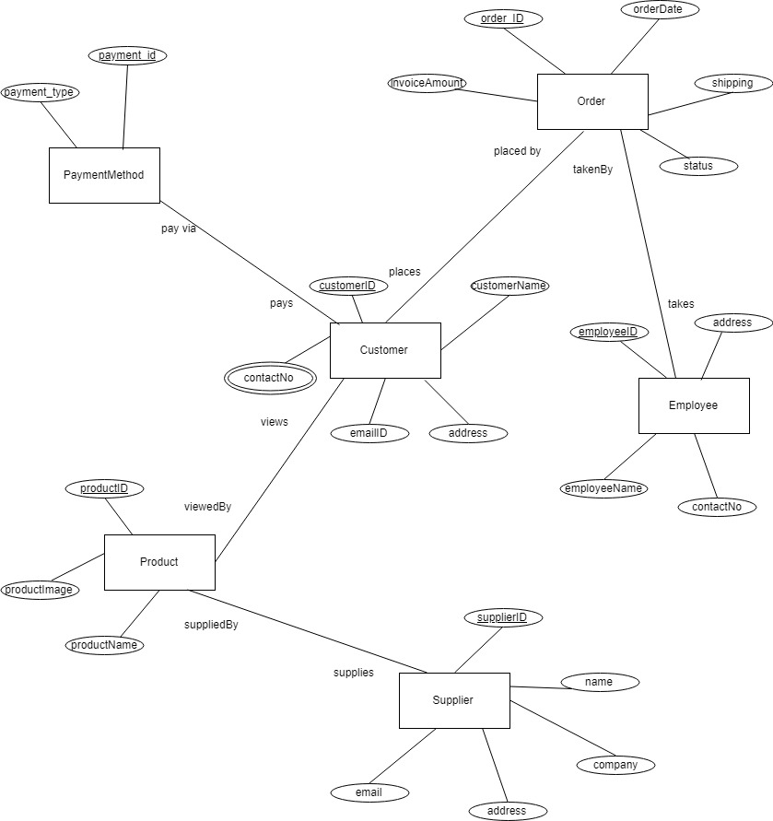

1. **ER Diagram**

**Author:** Vamsi Charan Adari **Date:** 09/11/2018

**10. DOMAIN CLASS DIAGRAM:**

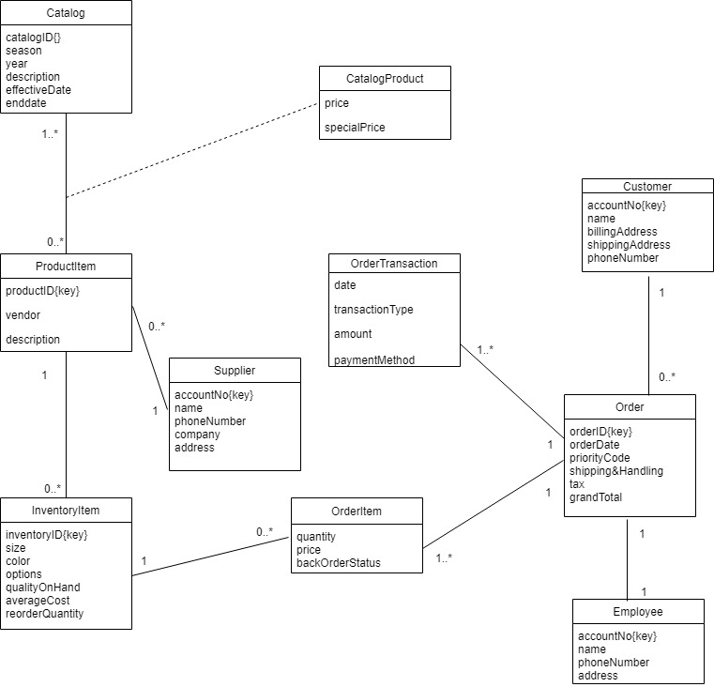

**10.1. Domain Class Diagram**

**Author:** Vamsi Charan Adari **Date:** 09/11/2018

1. **CLASS DIAGRAM**

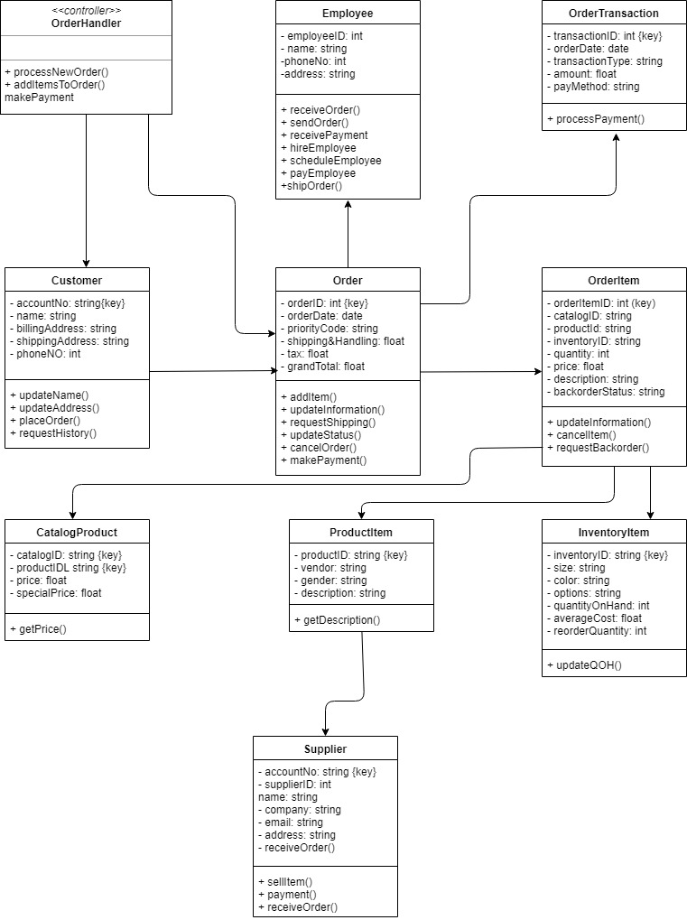

**11. Class Diagram**

**Author:** Vamsi Charan Adari **Date:** 09/11/2018

1. **CRC Cards:**

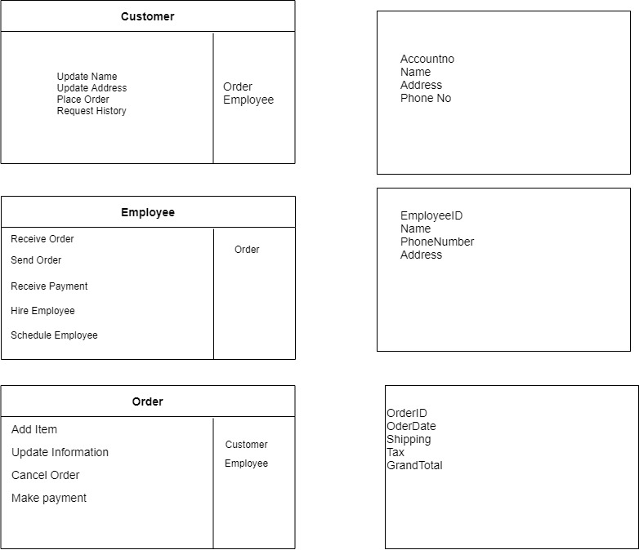

**12.1. CRC Card**

**Author:** Vamsi Charan Adari **Date:** 09/11/2018

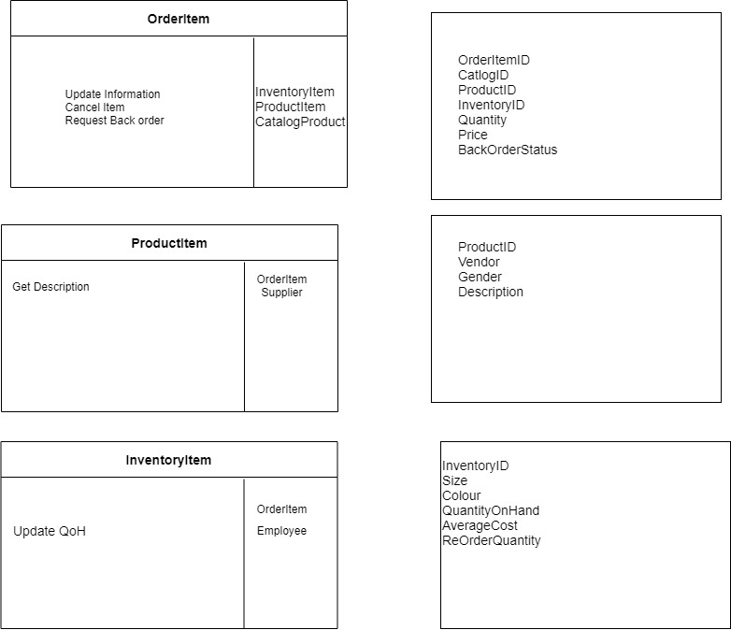

**12.2. CRC Card**

**Author:** Vamsi Charan Adari **Date:** 09/11/2018

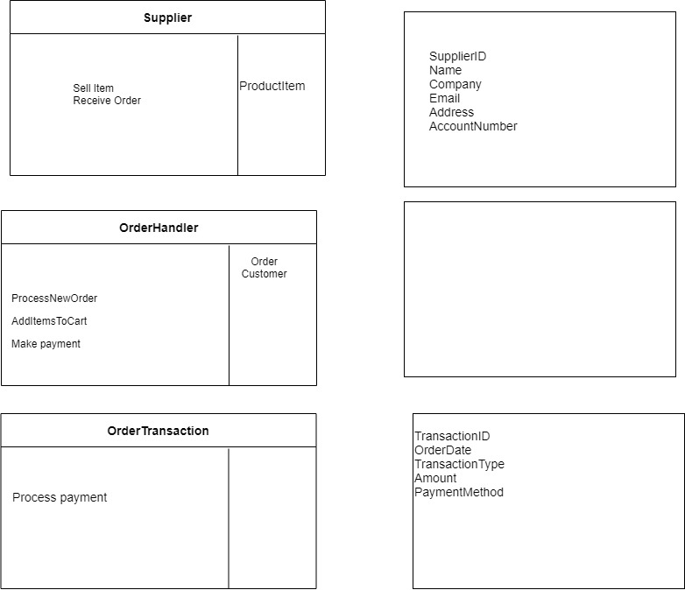

**12.3. CRC Card**

**Author:** Vamsi Charan Adari **Date:** 09/11/2018

1. **SEQUENCE DIAGRAMS:**

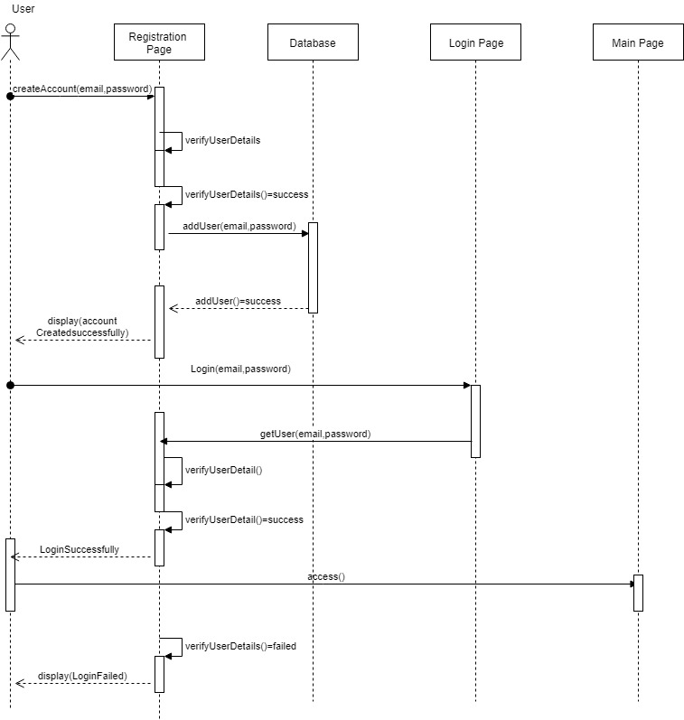

**13.1. Sequence Diagram**

**Author:** Vamsi Charan Adari **Date:** 09/11/2018

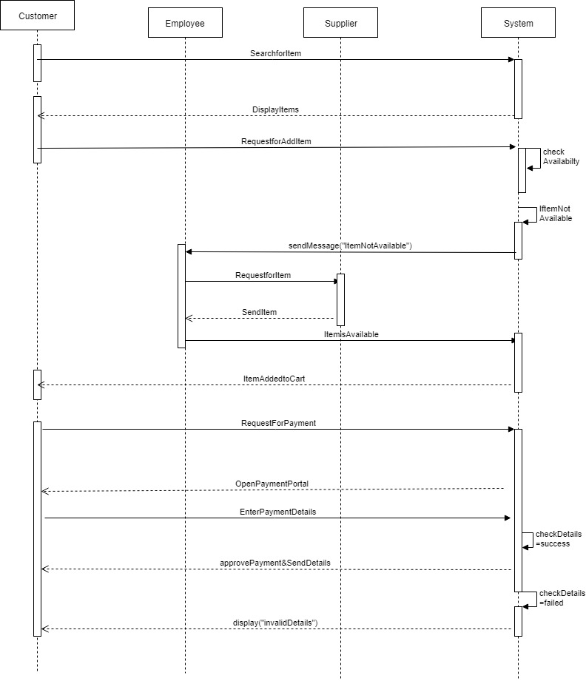

**13.2. Sequence Diagram**

**Author:** Vamsi Charan Adari **Date:** 09/11/2018

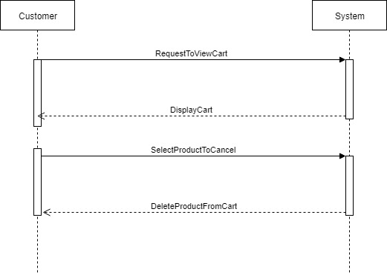

**13.3. Sequence Diagram**

**Author:** Vamsi Charan Adari **Date:** 09/11/2018

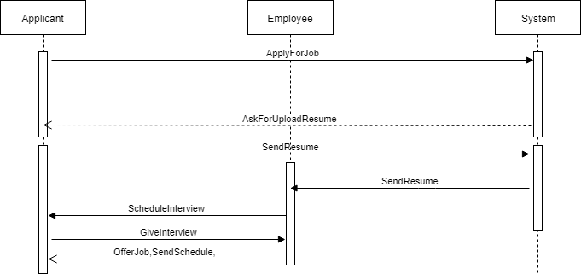

**13.4. Sequence Diagram**

**Author:** Vamsi Charan Adari **Date:** 09/11/2018

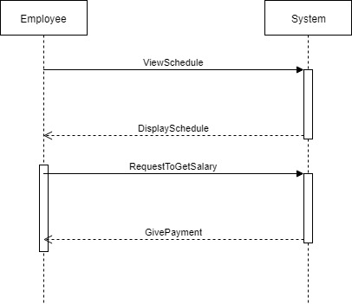

**13.5. Sequence Diagram**

**Author:** Vamsi Charan Adari **Date:** 09/11/2018

1. **COMPONENT DIAGRAM:**

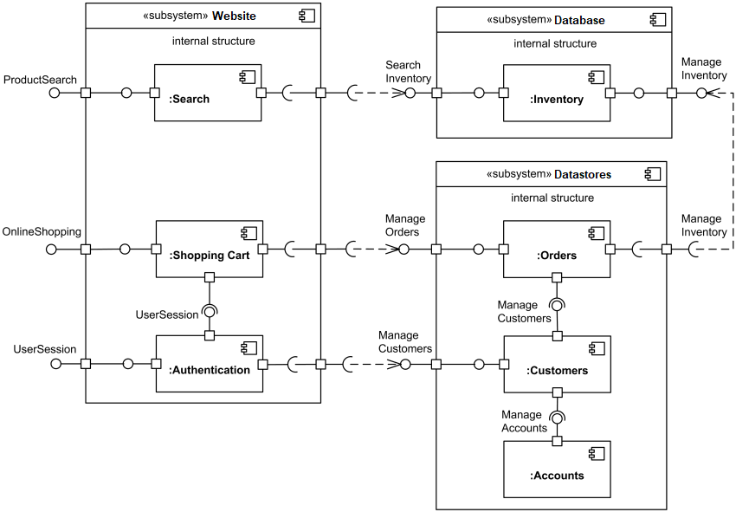

**14. Component Diagram**

**Author:** Vamsi Charan Adari **Date:** 09/11/2018

1. **DEPLOYMENT DIAGRAM:**



**15. Component Diagram**

**Author:** Vamsi Charan Adari **Date:** 09/11/2018

1. **GANTT CHARTS**

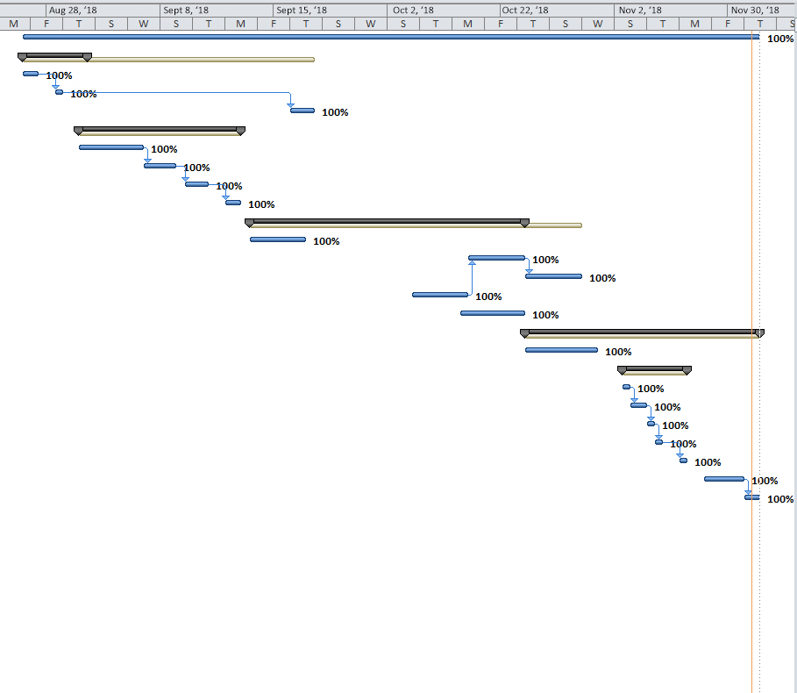

**16.1. Gantt Chart**

**Author:** Vamsi Charan Adari **Date:** 09/11/2018

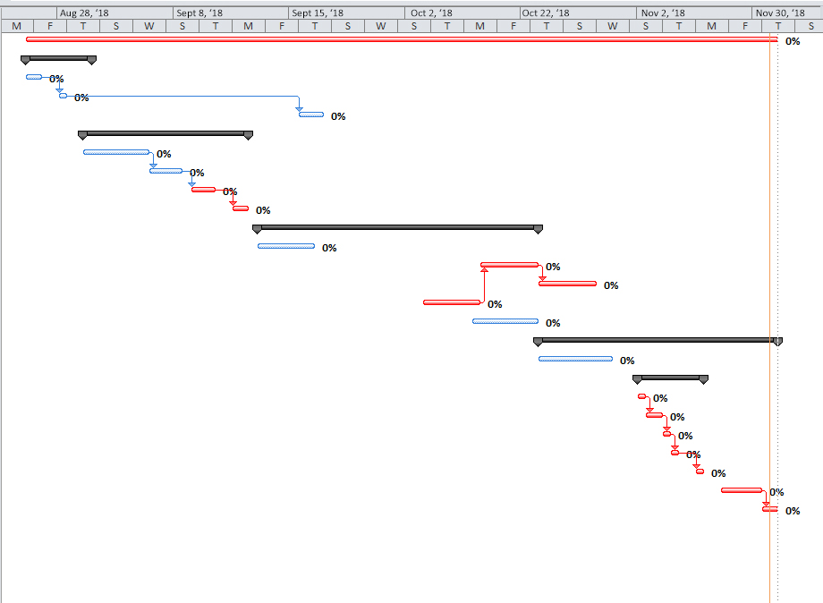

**16.2. Gantt Chart**

**Author:** Vamsi Charan Adari **Date:** 09/11/2018

1. **PERT NETWORK**

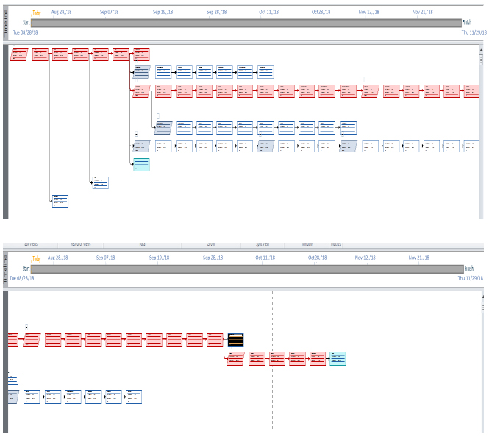

**17. Pert Network**

**Author:** Vamsi Charan Adari **Date:** 09/11/2018

1. **SYSTEM FLOW CHART**

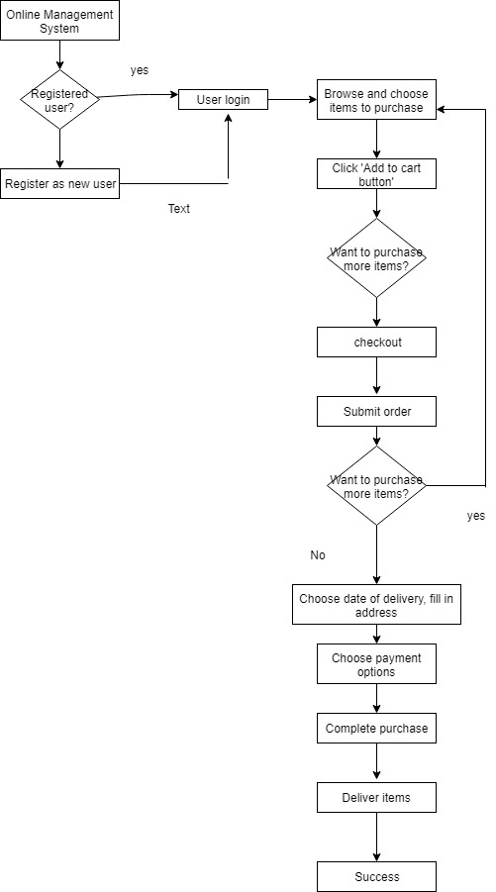

**18. System Flow Chart**

**Author:** Vamsi Charan Adari **Date:** 09/11/2018

1. **ETHICAL DILEMMA in this Project**

* This is a set of rules of a human moral behavior.
* Set of laws that dictate which activities in this society are deemed to be wrong.
* The competitive nature and dynamic environment within which retails operates, it is important to monitor the legal and ethical constraints affecting this sector.
* Employees should make sure that ethical behavior is demonstrated not only in how they act toward others but also in how they treat property that doesn’t belong to them.
* The key to success is in understanding who owns what & what boundaries exist for its use.
* The defrauding of a consumer of various projects and services which do not perform as advertised or overcharging or levying hidden charges through deceptive business practices.

1. **PROJECT EVALUATION BY TEAM MEMBERS**

* Research clearly shows the usage of project and future enhancements of a software.
* Project Metrics are clear every work is indicated properly.
* Table of contents organized exactly for each page numbers.
* Lot of improvements seen from Phase I and Phase II in case of diagrams, content, project description, PERT/ Gantt charts.
* Use case diagrams explained clearly for the complete project.
* Activity diagrams drawn for every use case shown in the use case diagram.
* Each activity diagram has screen design clearly shown and describing how it looks like.
* Slides organized, and visuals are good which are very explanatory.
* Sequence Diagrams are evenly relative to use case diagrams shows up entire project.
* Use case descriptions are clear every use case has a use case description, activity diagram.
* Class diagram exactly show the entire project the total class diagram and domain class diagram are very clear.
* State chart diagram is very explanatory easily understood about the states in the entire project.
* DFD diagram which includes context level, level 0 are very clear and each of them had good descriptions evaluated.
* E-R diagrams explain all the entities and their attributes.
* The Component diagram, deployment diagram and System flow chart makes sense.
* Including the time sheet also shows the exact completion of a project.